Mid-Term Impact Evaluation Report for

Adaptation Fund supported Project
“Enhancing Adaptive Capacity and Increasing Resilience of Small and Marginal Farmers in Purulia and Bankura Districts of West Bengal”

Implementing Country: INDIA Implementing Entity: NATIONAL BANK FOR AGRICULTURE
AND RURAL DEVELOPMENT (NABARD)
Executing Entity: Development Research Communication and Services Centre (DRCSC)

Period of Assessment: 2016/17 – 2018/19
Time of Evaluation: FEBRUARY 2020

Report Submission: OCTOBER 2020
Modified Report Submission: 15th March 2021

Evaluator: Dr Saudamini Das, Institute of Economic Growth, Delhi Email: saudamini@iegindia.org;
Phone: +919899066456, 01127667424

(ext-255)

Acknowledgement
This evaluation work was undertaken under the Research and Development Project Grant funding of the Department of Economic Analysis and Research (DEAR) of the National Bank for Agriculture and Rural Development (NABARD), Mumbai HO. I sincerely thank DEAR, NABARD for giving the opportunity to evaluate this project and for providing logistical help to meet the executors, stakeholders and beneficiaries of the project. Special words of thanks go to K. L. Prabhakar and B. Suri Babu for their continuous support during the evaluation process. Sincere thanks go to the office bearers of DRCSC, West Bengal and villagers and stakeholders of the project for their help, cooperation and enthusiastic participation in all project assessment related work. Sanju Yadav provided efficient research assistance.

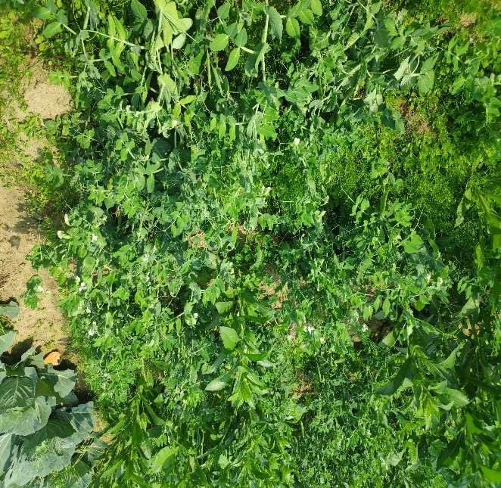
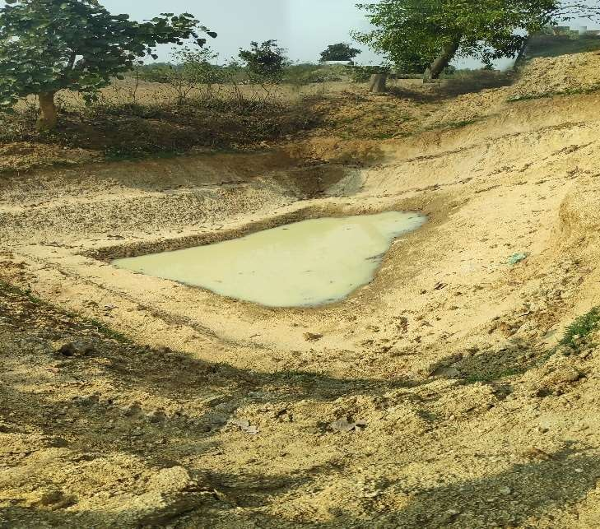

Some of the popular interventions, nutrition garden and farm pond, under the project

S

S

Mid-Term Evaluation Report for Adaptation Fund Project “Enhancing Adaptive Capacity and Increasing Resilience of Small and Marginal Farmers in Purulia and Bankura Districts of West Bengal”

Executive Summary

The Adaptation Fund funded project “Enhancing Adaptive Capacity and Increasing Resilience of Small and Marginal Farmers in Purulia and Bankura Districts of West Bengal” was implemented in Purulia and Bankura districts of the state of West Bengal, a sub-humid climatic region with Red and Lateritic soil. This project was specifically designed for such an agro- climatic zone and implemented by National Bank for Agriculture and Rural Development (NABARD) and executed by Development Research Communication and Services Centre (DRCSC), Kolkata. NABARD regional office including the district development offices and various departments of the state government including the block and panchayat level administration were the other stakeholders of the project. The project aimed at strengthening the capacity of small and marginal farmers of the region to adapt to climate change by helping them to build resilient livelihoods. Nearly 40 villages from Sonathali Gram Panchayat of Kashipur block of Purulia district and Ghosergram and Jhunika gram panchayats of Chhatna block Bankura district, which are representative of the red and lateritic soil and semi-arid region of West Bengal, had the interventions (Figure 1 below). The intervention sites were closely located and in total, 5000 households, who belonged to socially marginalized classes, were small and marginal farming communities dependent on natural resources for livelihood and below the

poverty line, were the project beneficiaries. The project implementation started from May 2015 and the mid-term evaluation was done during 4th to 6th of February 2020.
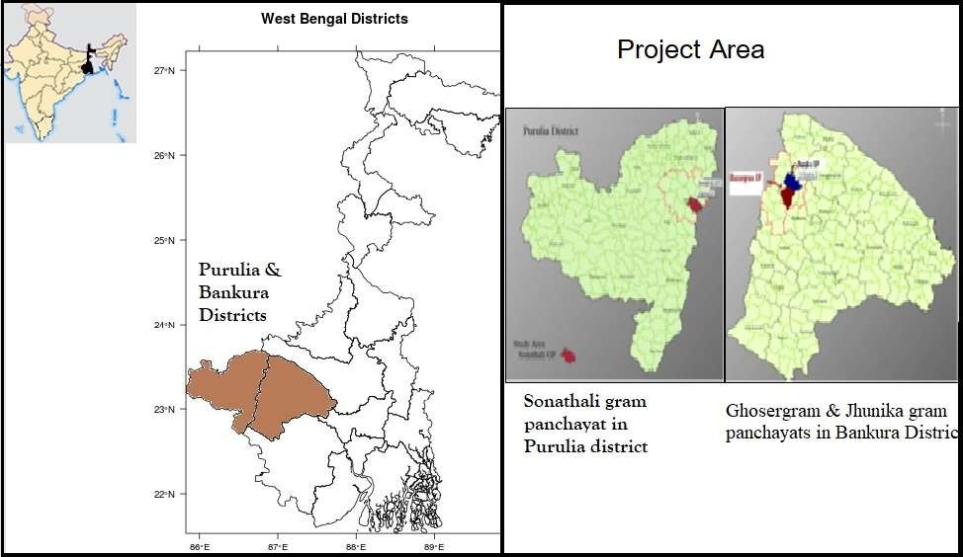

Figure 1: Project Area in Bankura and Purulia districts of West Bengal Objectives and Interventions of the project
Goal:
The primary goal of the project was to develop climate adaptive and resilient livelihood systems for the 5000 small and marginal farmers associated with agriculture and allied sector through diversification, technology adoption and natural resource management. As mentioned before the interventions were specific to the Red and Lateritic Zone of the state.

Expected outcome:
- Communities adopt land and water use master plans with the help of Panchayats through better understanding of climate change related impact.
- Farmers are better prepared for climate resilient agriculture and wastelands development.
- Livelihoods are less vulnerable to climate change and have higher levels of productivity.
- Upscaling the activities to improve climate resilience in other red and lateritic zones through publication of detailed materials on processes and techniques.

Interventions/Activities:

- Land & Water use master plans prepared at the gram panchayat level
- Installation and broadcast of timely and appropriate weather specific crop/agro-advisory services in local language (Bengali)
-- Installing Automated Weather stations at 6 locations,
--12 manual data collection centres
-- Preparing 5 days crop-weather advisories.
-- Development of Climate Resource Centre and

-- 40 weather Kiosks managed by climate volunteers

- Climate resilient technology transfer for enhancing the adaptive capacity

-- Sustainable soil and water conservation measures (e.g. semi-circular bunds, check dams, gully plugs, infiltration ditches and agro forestry plantations);
-- Multilevel cropping systems & integrated farming practices (drought tolerant field crops, fast growing & multipurpose perennials and small livestock);
-- Village level disaster-coping mechanisms like community grain banks, local crop & trees seed banks, fodder banks developed;
-- Promotion of climate resilient technologies like energy efficient cook stoves, bio-gas, low cost water filters and community based drinking water facilities

- Learning and Knowledge Management

--Production of technical and financial data
-- Production of short films, dedicated website and other printed materials
--Advocacy with National / State / Local Government and others like NGOs, CBOs, International organizations, climate activists/experts on processes and practices adopted under the project

Objectives of evaluation

This evaluation was undertaken for a mid-term assessment of the following points:

- Initial outputs and results of the project
- Quality of implementation
- Financial management
- Risk management
- Assumptions made during the preparation stage, particular objectives and agreed upon indicators and current status
- Factors affecting the achievement of objectives;
- M & E systems and their implementation
- Important learning
- Present status of documentation
- Suggestions for mid-course correction/improvements

Methodology of Evaluation

Evaluation was done following a qualitative approach to assess the project status and the beneficiaries’ perception of the project. The following activities were undertaken:
- Focus Group Discussions (multiple),

- Physical checking of project interventions inside the villages and verifying the suitability and benefits derived from the interventions from the opinions of the beneficiary households,
- Field verification of Interventions like farm bunds, farm ponds, check dam repair, agro-meteorological advisory stations, lift irrigation, seed banks, etc.
- Visit to vegetable gardens, aquaculture sites, cow sheds, goat sheds, etc.
- Examination of Project documents and data registers,
- Verification of the assessment tables prepared by DRCSC as assigned to them

The multiple focus group discussions and the visit details are described later in the document. The objectives were discussed with the beneficiaries, project partners, implementers and also with non-beneficiaries (neighbors, researchers working in the project area, etc.). Multiple visits were undertaken to different project sites and multiple focus group discussions were organized to know beneficiaries knowledge, gains and losses (if any) and their perception regarding what more needs to be done or should have been done differently and whether they are going to continue with the interventions introduced under the project after the completion of the project period and withdrawal of the implementing/executing agencies.

Main findings

The extensive field visit and interaction with villagers and government officers provided good evidence that the project is going well and helping people to reduce the stress from weather shocks. Opinion of people in different meetings indicated their appreciation and acceptance of the project activities. Government officers of agriculture department of Purulia district and block development officer of Chhatna block, Bankura district showed their keenness to extent the project activities in the future, which is an indicator of the project success. In every village level meeting, the beneficiary households and village development committee members participated with lots of enthusiasm and looked to be happy with the project interventions. Women members were present in large number and participated fully in all discussions. The drinking water projects, the lift irrigation project, the vegetable gardens, the smokeless chulhas, the biogas plants were all in good condition and working well. Livestock related interventions also had good acceptability and except few, most households were doing well. The farm ponds had water though the visits were in the month of February. The pond site selection seemed appropriate and the ridge to valley approach followed by the agency to select the pond site seemed to be giving good result. The agro-advisory services, which are being provided in local languages, seemed to have helped farmers avoid losses of ripe crops from sudden and unseasonal rains.

Quality of implementations

Some 40 villages and 5000 households were covered under the project and nearly 15% of them were inspected during the mid-term assessment. From field verification and as per data provided by the agency, some 60% of the work has been completed and rest is yet to be taken up. The work completed in 4.5 years i.e. from May 2015 till December 2019 is 60%, the rest 40 % have to be completed within one year before project completion date, which is a high hope target. Thus, the implementation status can be said to be less than adequate. However, the quality of implementation in all inspected villages seemed satisfactory and giving expected outcome. Description of detailed results, later in the report, shows item/intervention wise status and ratings.

Physical impacts and benefits to households

The impact of the project on well-being and adaptability of people was not accessed carefully in this study. This requires a proper impact evaluation after the study period. However, interaction with villagers and specific women groups made it obvious that people are happy and gaining benefits from the interventions. The kitchen cum nutritional gardens, wherever visited, were in good shape with healthy plants and household heads reported to be earning good revenue by selling the vegetables. The natural cropping pattern has reduced the cost of cultivation and that is a big incentive to all villagers, and they are gaining good revenue at the same market price. Their crop loss from unseasonal rains have reduced due to agro-meteorology services and thus, adding to their wellbeing.

With multiple awareness training, regular dissemination of crop advisories, appointment of volunteers to motivate the farmers, regular interaction with beneficiaries, the villagers have been made aware of climate change and the possible risks coming from there. This was very much visible in all meetings. They all seemed to be well versed with the natural production and water saving techniques. All these have strong positive impacts on the climate adaptability of small and marginal farmers.

Challenges

The project faces multiple challenges, mainly from change of government officers and lack of support from new ones. Many government programs are repetitive of what is being done under the project and agency has to take extra efforts to convince the government and panchayati raj representatives to establish complementaries between the government work and work done under the AF project and bring out work synergies. The other challenge comes from illiterate farmers who are hard to be convinced. However, as described under the risk management section later, the agency has worked hard to manage these challenges and turn them to advantages.

Lessons learnt

Some of the highlights of the project were the following:

- Most of the beneficiaries are very poor, marginal and small farmers or landless laborers.
- Most of them are either scheduled caste, scheduled tribes or other backward castes and the project is highly tilted towards social justice.
- In almost all villages, women seem to be in the forefront and more than equal beneficiaries.
- The project has created lots of enthusiasm among the beneficiaries and they seem to be highly motivated to continue the work after the project period is over.

- With scientific input provided by Jadavpur University, the water related interventions (ridge to valley approach) seem to be quite successful in this project area.
- The natural farming adopted by small holders need market support and most of them request to arrange for a segregated market in the name of “organic market (no certification needed)” to sell their products without any price premium. The farmers are confident to earn profit and attract other farmers towards organic and ecological farming (as they are doing under the project) as there is lot of demand for organic products in the area and a separate market will help consumers to identify and buy these products. The cost of production being low, the farmers will earn profit at the same prevailing market price and an assured market will help them to continue.
- The crop-weather advisory in local language also seemed to be very helpful and farmers are getting multiple helps because of it.
- Some of the beneficiaries became emotional while thanking NABARD for helping them with the project.

Limitations and replicability

  - Though the project beneficiary selection is strongly titled towards social justice, it does not seem to be representative of the farming class of the district. Only marginal farmers have been given the farming related interventions and all the experimental fields were very small in size. As the area has small, medium as well as large farmers, the project beneficiaries should have been a mixed group. Thus, suitability of climate resilient farming approaches, being taught by this project, are not being tested in medium to large plot sizes and this limits the upscaling of the interventions. The project should have adopted a representative sample, even after giving priority to social justice, to claim that Adaptation Fund project is making farmers ready to adapt to climate change.
  - There are too many interventions in every village and it gives the impression that project beneficiaries are only jack of everything, master of none. Whether intensive learning is happening or not is difficult to say.
  - There is too much of propaganda and show off, like huge Adaptation Fund Project Board, in front of each of the project village and many of them are not even visible or writings have got erased. This seemed to be a waste of money.
  - Barring these points, the project seemed to have improved the climate adaptability of socially vulnerable groups and can be replicated with similar households elsewhere with similar geo-physical features.

Table of Contents
EXECUTIVE SUMMARY 3
Objectives and Interventions of the project 4
Expected outcome 4
Interventions/Activities 4
Objectives of Evaluation 5
Methodology of Evaluation 5
Main Findings 6
Quality of implementations 6
Physical impacts and benefits to households 7
Challenges 7
Lessons learnt 7
Limitations and replicability 8
Acronyms 10
List of Tables 11
List of Figures 11
- Introduction 12
- Evaluation and Findings 12
  - Aggregate Outcome Tracker 14
  - Item-wise Result tracker 16
  - Village wise result tracker 16
  - Rating of the implementation process 17
  - Risk Assessment and Present Status 17
  - Documentation details 19
  - Stakeholders Involvement 19
  - Financial assessment 20
- Other Observations from the field 20
- Some limitations 20
Tables 21

ACCRONYMS

Acronyms | Description
ADM | Additional District Magistrate
AWS | Automated Weather Station
BCKV | Bidhan Chandra Hrishi Vidyalaya
CBO | Community Based Organizations
CRC | Central Review Committee
CSR | Corporate Social Responsibility
DEAR | Department of Economic Analysis and Research
DFO | District Forest Officer
DM | District Magistrate
DRCSC | Development Research Communication and  Services Center
FGD | Focus Group Discussion
FPO | Farmer Producer Organization
HH | Household
HO | Head Office
KVIC | Khadi and Village Industries Commission
MDCC | Manual Data Collection Center
MGNREGA | Mahatma Gandhi National Rural Employment  Guarantee Act
NABARD | National Bank for Agriculture and Rural  Development
NGO | Non-Government Organization
PBSSD | Paschim Banga Society for Skill Development
PRI | Panchayati Raj Institutions
SHG | Self Help Group
WBREDA | West Bengal Renewable Energy Development  Authority
ZP | Zila Parishad

List of Tables

Table No. | Description | Page
Table 1 | Details of Field visit to Purulia and Bankura districts | 11
Table 2 | Aggregate Outcome Tracker | 19
Table 3 | Item-wise Result tracker (Prepared & submitted by DRCSC) | 22
Table 4 | INDICATOR TABLE (Comparison of baseline, target and  present status) | 23
Table 5 | Village wise Result Tracker | 30
Table 5A | Description of interventions | 32
Table 6 | Rating on the Implementation Progress | 33
Table 7 | Risk Assessment for Outcome 1 & 2 | 35
Table 7A | Risk Assessment for Outcome 3 & 4 | 37
Table 8 | Record keeping and documents being maintained | 40
Table 9 | Stakeholder Involvement and Output-Outcome Status | 41

List of Figures

Figure No. | Description | Page
Figure 1 | Project Area in Bankura and Purulia districts of West Bengal | 4
Figure 2 | The Sites Sonathali Gram Panchayat (left) and Ghosergram  and Jhunika gram panchayats (right) | 12
Figure 3 | Pictures from the field showing interventions and beneficiaries | 50

Mid-Term Evaluation Report for Adaptation Fund Project “Enhancing Adaptive Capacity and Increasing Resilience of Small and Marginal Farmers in Purulia and Bankura Districts of West Bengal”

Introduction

The Adaptation Fund funded project “Enhancing Adaptive Capacity and Increasing Resilience of Small and Marginal Farmers in Purulia and Bankura Districts of West Bengal”, executed by Development Research Communication and Services Centre (DRCSC), Kolkata, aimed to strengthen the capacity of small and marginal farmers of the region to adapt to climate change by helping them to build resilient livelihoods. The project was implemented in a sub-humid climatic region with Red and Lateritic soil and interventions were tuned to the specific requirement of this biogeography. The objective was that once the livelihood models are proved successful, then they can be replicated in similar agro-climatic zones. The intervention area was 40 villages from Kashipur block of Purulia district and Chhatna block of Bankura district, which are representative of the red and lateritic soil and semi-arid region of West Bengal. Further the villages were from Sonathali Gram Panchayat of Kashipur block and Ghosergram and Jhunika gram panchayats of Chhatna block (Figure 1 below).
The intervention sites were closely located and in total, 5000 households, who belonged to socially marginalized classes and were vulnerable small and marginal farming communities dependent on natural resources for livelihood and below the poverty line, were the project beneficiaries. The project implementation started from May 2015 and the mid-term evaluation was done during 4th to 6th of February 2020.

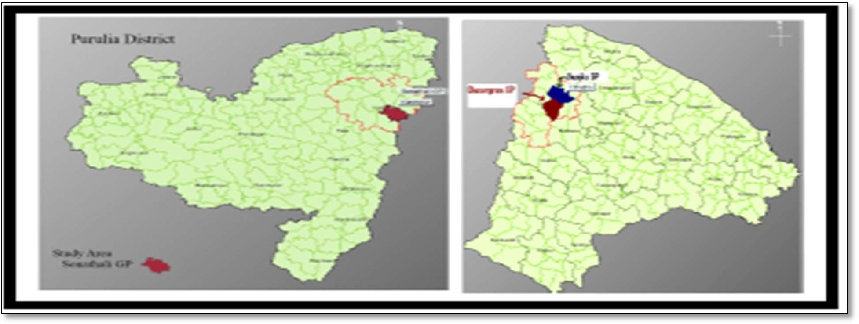

Figure 2: The Sites Sonathali Gram Panchayat (left) and Ghosergram and Jhunika gram panchayats (right)
The evaluation was undertaken for a mid-term assessment of the following points:

- Initial outputs and results of the project
- Quality of implementation
- Financial management
- Assumptions made during the preparation stage, particular objectives and agreed upon indicators and current status
- Factors affecting the achievement of objectives;
- M & E systems and their implementation
- Important learning
- Present status of documentation
- Suggestions for mid-course correction/improvements

Accordingly, these points were discussed with beneficiaries, project partners, implementers and also with non-beneficiaries (neighbors, researchers working in the project area, etc.). Multiple visits were undertaken to different project sites and many focus group discussions were organized to know beneficiaries knowledge, gains and losses (if any) and their perception regarding what more needs to be done or should have been done differently and whether they are going to continue with the interventions introduced by the project after the completion of the project period and withdrawal of the implementing agency.

Evaluation and Findings

As mentioned above, both qualitative and quantitative approaches were used to assess the project status and the beneficiaries’ perception of the project. Activities undertaken were the following:
  - Focus Group Discussions (multiple),
  - Physical checking of project interventions inside the villages and verification of the suitability and benefits of the interventions from the opinion of beneficiary household,

  - Examination of Project documents and data registers,
  - Organizing Special group meeting for women
  - Checking and field verification of Interventions like farm bunds, farm ponds, check dam repair, agro-meteorological advisory stations, lift irrigation, seed banks, etc.
  - Visit to vegetable gardens, aquaculture sites,
  - Visit cow sheds, goat sheds, etc.
  - Check and verify the assessment tables prepared by DRCSC as assigned to them
Issues like project progress and benefits to villages, difficulties faced, what more needs to be done, special arrangement for women and poorer section of society, etc. were discussed with the representatives of project villages either by organizing a meeting in their village or by calling them to the nearby villages where the FGDs were organized. Table 1 below shows the details of the field visit conducted during 4th to 6th of February 2020. Interactions with West Bengal government officers in the field area, villages visited, interventions verified, and some inferences from these meetings are described in the table.

Table 1: Details of Purulia and Bankura Field visit

Date of visit | Project partner/village visited | Purpose of visit/ Interventions verified
Meeting with West Bengal Government Officers linked to project
04/02/2020 | Mr. Sajal Bhowmick Project Director, ATMA Department of Agriculture  Purulia district | The agency has been working in close coordination with these officials and trying to establish synergy between the project and projects implemented by these government departments.  These government officials also seemed to be satisfied with the AF project outcome and promised to continue the work after the project duration gets over.
Dr.Asish Bandopadhya Deputy Director of Agriculture (administration)
Department of Agriculture Purulia District
Mr. Soumen Belthoria Karmadharshy - Janasasthay & Karigari Bibhag
Purulia Zila Parishad
06/02/2020 | - Saswati Das, BDO & EXE, CHHATNA (BANKURA), WBCS  - Bankim Mishra, political leader  - Shyamal Roy, Fishery Extension Officer
Visit to different project villages
04/02/2020 | Village-SURA; Block-KASHIPUR, District-PURULIA | - Step pond  - Breeding unit (SHEEP) – group based/ floor improvement/urine store  - Rabbit Rearing  - Nutrition Garden  - Cultivation in fallow land (Row inter-cropping)
 | Village-SEJA; Block-KASHIPUR, District-PURULIA  And  meeting with some farmers at Purulia Project Office | - Community managed drinking water including Nutrition Garden by using waste water  - Meeting with Community  - Growing season extension by using water from dug well (SASADHAN MANDI)  - Group based breeding unit (PIG)

 |  | 5. Individual Piggery
05/02/2020 | Village-USHARMUKTI Block-KASHIPUR, District- PURULIA | - Soil and Water conservation (hill) (Staggered Trench)  - Arjun plantation including 30X40 model  - Mixed cropping by using water of step pond  - Ditch (HAPPA) in Medium Upland  - Mixed orchard Plantation including 30X40 (water recharge)
 | Village-BELDI, PURULIA | - 2 Ditch (farm pond)- under construction  - Commercial vegetable cultivation (organic + mixed cropping)  - Bio gas plant  - Smokeless oven
 | Village-PABRAPAHARI,  PURULIA | 1. Complete step pond, 2. 3-4 Nutrition Garden
 | Village-PORADIHA; BANKURA | 1. Step Pond, 2. Growing season extension
 | Village-HENTASURA, BANKURA | 1. Ditch, 2. Dug well, 3. Cultivation
 | Meeting with some farmers at Joyonagar Community Centre [Villages covered- Penchasimul, Bishkodor, Hetasura,  Joynagar, Jamthol and Poradiha], BANKURA | Though few people came from these villages, all were highly motivated, happy with project outcome and likely to continue the activities after the project period.
06/02/2020 | Village-PENCHSIMUL and  Chingri, BANKURA | 1. Garden, 2.Small ruminant, 3. Well/ pond, 4. Incubator water filter
 | Village-Suara Bakra – Tola- Chhachanpur, Bankura | RLI/ Display board/ Seed Bank/ AWS
 | Village-Besara – Tola- Beriathol, Bankura | - Common facility centre managed by FPC  - Automated Weather Station (AWS)  - Community managed drinking water  - Meeting with watershed committee (2 committee members)  (participants from 11 villages)
 | Village- Dakshin hansapahari, Bankura | - Check dam- convergence with MGNREGS  - Relay cropping- linseed/ lathyrus  - Hapa/ditch – vegetable cultivation  - Step pond- under construction  - Grain bank  - Meeting with female & male members at Dakshin Hansapahari

Government officers of agriculture department of Purulia district and block development officer of Chhatna block, Bankura district showed their keenness to extent the project activities in future, which is an indicator of the project success. In every village level meeting, the beneficiary households and village development committee members participated with lots of enthusiasm and looked to be happy with the project interventions. Women members were present in large number and participated fully in all discussions. Maximum discussion were on diversified livelihood issues, organic farming/manure, drinking water provision, etc. The common opinion of almost all village participants was the usefulness of agro-advisory services which are being provided in local languages. Some of the pictures of the FGDs are shown in the appendix.

Next, the output/outcome wise interventions, the status so far, the level completed, village wise details, risk assumptions, steps taken to address them and present status of risks, role of stakeholders in different component of projects and present status, status of documentation, etc. were assessed quantitatively with
the help of different tables, which are either shown at the end of the document. First, the aggregate outcome tracker is discussed which is then followed by item-wise result tracker as per the interventions, the village wise results tracker, implementation success indicator, risk assessment, stakeholders’ involvement, and documentations being maintained. Lastly, the lessons learnt and evaluator’s opinion regarding what is working and what more needs to be done for better and sustainable results are described.

2.1 Aggregate Outcome Tracker

Table 2 at the end describes the status of the expected outcomes by December 2019. Though the expected final outcomes should ideally be analyzed after the project completion as the real behavioral change can be seen only when executing agency is not in the area motivating people to adapt to climate resilience activities. But a trajectory can be seen by evaluating how people have adapted to these interventions till December 2019. Almost 5000 HHs practice climate risk reduction measures introduced through project interventions. Around 85% of HHs in both districts, Purulia and Bankura, are able to take informed decisions about climate adaptive intervention. Thus, more than 80% of 5000 HHs are taking the interventions seriously. Almost 90% of Gram Panchayats use land and water use master plan at the time of making Village Development Plans. Crop advisories in local language have been proved to be very useful by farmers, 6,368 farmers in Purulia and 17,245 farmers in Bankura were getting these advisories till December 2019. Total 320 advisories have been disseminated till December 2019. One climate resource centre has been established in Purulia and 40 weather kiosks are in place in both the districts. This tracker claims that the aggregate farm productivity have been increased by 36% & 38% for at least 73% &76% families in Purulia and Bankura respectively. More than the target, 400 ha of single crop land in the project area have turned into double crop area. Out of 250 ha of land to be brought under vegetative cover and agro forestry systems, only 26.93 ha &
81.53 ha in Purulia and Bankura respectively have been covered till December 2019. Thus, more focus is needed in increasing vegetative cover to achieve the targets set. Out of 4000 target families, approximately 65% have reduced their dependence on market for the inputs for agriculture. 17 grain banks in Purulia and 6 in Bankura were completed till December. Input crisis were met up by 1135 HHs in Purulia and 1225 HHs in Bankura through these interventions.
Energy efficient oven use in Purulia (872) is double of that in Bankura (433) but the bio gas and low cost filters installed in Bankura (bio gas- 8, low cost filter-65) are much more than in Purulia (bio gas- 66, low cost filter-265). Project interventions are being widely accepted in different areas like BCKV getting support and improved seeds from agency, training being provided to PBSSD (Govt. of WB) on climate resilience measures, drought tolerate seed support to Purulia Agriculture Department, etc. Thus, outcome wise the situation seems to be satisfactory.

2.2 Item-wise Result tracker

Table 3 shows the item-wise result tracker for all the interventions. As per this table interventions are either completed or improved except one intervention (multipurpose plantation in 20 ha of common land) which could not be completed due to the change in policy of state government. There are no deterioration or no-improvement cases. As described in the table, project inception workshop was completed on time with the initiation of the project. All major structures like Automated Weather Stations, Manual Data Collection centers, Climate Resource Centre, Weather kiosks, which were planned to be established, have been built and are functioning well. To assist farmers in understanding crop weather advisories 246 awareness meetings have been conducted either by government officers’ visit, expert visit, self-help group meetings, etc., which has helped in increasing the number of beneficiaries from such advisories. 29 ponds have been excavated by farmer groups, 3 check dams and 152 infiltration ditches have been constructed under the project and total 302 ha land area have been covered under soil water conservation measures like contour bunds, water absorption trenches, stone bundling of gullies, semi-circular bunds, 30X40 model. Seasonal drought tolerant crops have been planted on 40 ha of land on back side of bunds to prevent soil erosion. Thus, soil and water conservation interventions have been efficiently completed on time, resulting in improvements in the area. The status of all the 28 activities have been described in detail in the table. The descriptions in the table are self-explanatory.

Next, these descriptions of table 3 were compared with the Indicator table 4, where comparisons are drawn between the baseline, target set for the project and the status at the time of the mid- term assessment. This table also confirms the results shown in result tracker Table 3.

Village wise result tracker
As mentioned before the project covered 40 different villages where different activities were undertaken. Table 5 below shows the details, how many and what all are implemented in which
village. This table shows the village wise details like number of households, % of beneficiaries, representation of women in village committees, when was the project initiated in the village, how many interventions were introduced, what % of the work is completed by now, etc.
The interventions are shown as numbers (1, 2, 3, ) in the table and are described below in table 5A, As evident, the first few components of the interventions like GIS mapping, crop advisory services, climate kiosks have been completed in most of the villages. There is good representation of women in all village committees and except few, maximum villages have more than half (more than 50%) of the households as direct beneficiaries. On average, more than 10 interventions have been introduced in all the villages (except Majidih and Banjura), though the level of completion varies from village to village.

Rating of the implementation process
The ratings table (Table 6 below) show how satisfactory has been the implementation of the proposed interventions according to the executing agency. Water soil conservation measures are given only satisfactory ratings by them and not ‘very satisfactory’ as many villages are left where pond excavations have to take place. Three check dams are completed which will benefit only 450 HHs, 330 infiltration ditches are completed. Figures related to other measures like water absorption trenches, stone bundling of gullies, semicircular bunds were not given by the agency due to lack of time. Plantation of drought tolerant crops on back side of bunds were given very satisfactory ratings, but due to withdraw of brikkha patta scheme of MGNREGA in the target areas plantation on utilized common property resource were stopped after completion of plantation on 10 ha. Thus, this scheme received a low rating. Rest of the interventions got very satisfactory ratings, though some interventions are only partially completed like grain banks, seed banks, cook stoves, bio gas plants, etc. Four fodder banks have been developed but are not functioning very well, hence, less ratings given by the agency. Knowledge management is going well with four technical and economic analysis documents on improving climate resilience in red and lateritic zone, two short films, an updated website and various state level and local level workshops being completed.

However, when the data from all the tables are analyzed, the work completed is roughly around 50-60% of the target. With the completion of project date coming nearer and given low level of implementation, the ratings given by the agency seems to be misleading. The work completed in
4.5 years i.e. from May 2015 till December 2019 is 60%, the rest 40 % have to be completed within one year before project completion date, which is a high hope target. Thus, the implementation status can be said to be less than adequate.

2.5 Risk Assessment and Present Status
Two tables attached at the end (Table 7: Risk Assessment_Outcome 1&2, Table 7A: Risk Assessment_outcome 3&4) talk about the risk component of the project. As reported by the agency, newer risks are being faced in component 3 and 4 of the project outcome, mainly due to

change in some government policy and the agency is taking care to transform the risk to advantages. First, the assessment as given in Table 7 are described. The project objective faced risk of government not willing to prioritize, sustain and upscale the support for climate adaptive interventions in their strategies and plans. To improve this situation various meetings were organized with government departments on various aspects of climate resilient models and good rapport was built at all levels of government machinery to elicit positive response. As a result, the project activities of the AF project viz., promoting crop diversification, productive utilization of waste land, use of quality seeds & seed bank development, vermin-composting, smokeless chulhas, agro advisories to farmers, etc. have been included in the West Bengal State Action Plan and also under West Bengal Accelerated Development of Minor Irrigation Project which aims to enhance agricultural production of small and marginal farmers. Another problem was that government officials and PRI members may change during the period of project implementation which may result in unnecessary roadblocks by new officials like the withdrawal of Brikhaa Patta scheme leading to plantation intervention being stopped from any further execution. Meetings and awareness generation activities are conducted in regular intervals to prevent such roadblocks, though the risk still persists on medium scale according to the agency. The risk of not all farmers using the crop advisories is been tackled efficiently by regular group meetings and successful case stories being showcased to motivate farmers which has led to both literate as well as illiterates using the advisories now. This risk has now been reduced due to adequate steps taken by the agency. The problem of volunteer absenteeism for dissemination of crop advisory is solved by training interested youth from the villages to act on behalf of volunteers in their absence so that the community gets the crop advisories without failure.

For livelihood interventions, additional development support (financial and marketing) is not received at required time in target gram panchayats. Interaction with government officials and PRI members and linkages with SHG are developed to support various livelihood services under the project and get investment for entrepreneurial development activities. The fear of low efficiency due to grouping of farmers with similar economic and social status for pond excavation has been sorted out by capacity building with special focus on group leaders to solve group conflicts.
The prices have gone up in the project area due to new tax regime and purchasing power has increased due to minimum wages being received through MGNREGA in the area. Thus, to eliminate the risk of non-completion of project within sanctioned budget, beneficiary contribution is insisted to the extent of cost escalation.
Finally, the biggest risk to the whole project was Integrated Watershed Development Project (USHARMUKTI) under MGNREGA launched in West Bengal in August 2017. Total operational area of the project is being covered under this government project. The targeted HHs are showing more interest for the watershed related work (e.g. Earth work, Plantation etc.) under the schemes rather than the work of AF project implemented by DRCSC because the economic benefits are more under the government program. This was leading to duplication of work and

wastage of money under AF project. According to consensus arrived at, USHARMUKTI project will take new works and renovation work of old water structures will be done under the AF project. Due to the efficient implementation of works under AF project, synergy has been developed between the two projects and the USHARMUKTI project has now come under the AF project. Thus, the risk has been converted to a helping hand and now the government and DRCSC are helping the villagers together.

Documentation details

Table 8 shows the type of records being maintained and their frequency. Since the project inception, documents are being maintained regularly at different levels and with varying frequency. Some are daily records, some are being maintained at weekly intervals, some at monthly intervals, some are quarterly and some are seasonal. Some are at the level of households, some at the level of FPO and most are being maintained at the office of the agency, DRCSC, depending on the purpose and future use.

Stakeholders Involvement
Other than DRCSC, who were the executing agency of the project, Other stakeholders were (i) Oceanography Department of Jadavpur University, (ii) Communities of 5 Gram panchayats, (iii) PRI Members & Government Officials, (iv) Expert Group comprising of Meteorological and Agricultural Experts, (v) Climate volunteers and local farmers, (vi) NABARD Regional Office in Kolkata District, (vii) Rural Development Department, (viii) Water Resources Development Dept., Animal Resources Development Dept. and (ix) Departments of Agriculture, Horticulture, Fisheries, KVIC, WBREDA, Engineer. Table 9 describes the role and level of involvement of different stakeholders in the project. As per this table, community level Village institutions are in place. CBOs are regularly meeting to discuss issues including forest conservation and regular training is given to improve community participation around conservation.
Village level trainings every month are given to farmer groups, especially women farmers on various improved agricultural practices, livestock care, poultry rearing etc. For gender focused activities, habitation level “Mahila Sabha” is created where women meet at least once in a month to discuss village level and gender based issues and take actions on them if needed. This sabha also gets training on improved agricultural practices and training for rearing poultry by a special cadre called “Pashu Sakhi”. Participatory impact monitoring is in beginning stage as only restored commons and private lands are been monitored till now. For climate resilient agriculture, creation of water bodies for critical irrigation (farm pond), creation of low cost water bodies (bori bandhan), and renovation of existing water bodies (de-siltation, repairing& gating mechanism in stop dam), field bonding activities are under progress. Water related entry point activities have done in all the project villages. Process of supporting and supplying advance water use technologies to the farmers in the project villages is under progress. Farmers are adopting climate resilience cropping practices after getting trainings on crop diversification, vegetable farming, etc.
For skill development, various skill training institutes are identified and enrolled by the stakeholders; expert organizations are also being engaged. For energy efficiency, bio-gas plants, smoke less fuel and solar light is being used by the villages and soon the target for energy efficiency will be achieved. Two consultative workshops have been conducted; one video prepared and case studies workshops are under progress for knowledge dissemination from the project. Designing of website for dissemination of information related to the project for use by stakeholders is under progress.
Though the agency DRCSC was asked to separately describe the role played by different stakeholders in course of the project work in Table 9, the agency only repeated what activities have been done. They did not specify the exact role played by stakeholders in different activities. In spite of repeated request, we could get no detailed information and have reported what was shared with us.

Financial assessment

The agency did not share any information regarding the financial allocation or how much has been spent on what heads. So no assessment could be made.

3 Other Observations from the field

The extensive field visit and interaction with villagers and government officers provided good evidence that the project is going on well and helping people to reduce the stress from weather shocks. Some of the highlights of the project were the following:
- Most of the beneficiaries are very poor, marginal and small farmers or landless laborers.
- Most of them are either scheduled caste, scheduled tribes or other backward castes and the project is highly tilted towards social justice.
- In almost all villages, women seem to be in the forefront and more than equal beneficiaries.
- The project has created lots of enthusiasm among the beneficiaries and they seem to be highly motivated to continue the work after the project period is over.
- With scientific input provided by Jadavpur University, the water related interventions (ridge to valley approach) seem to be quite successful in this project area.
- The natural farming adopted by small holders need market support and most of them request to arrange for a segregated market in the name of “organic market (no certification needed)” to sell their products without any price premium. The farmers are confident to earn profit and attract other farmers towards organic and ecological farming (as they are doing under the project) as there is lot of demand for organic products in the area and a separate market will help consumers to identify and buy these products. The cost of production being low, the farmers will earn profit at the same prevailing market price and an assured market will help them to continue.

- The crop-weather advisory in local language also seemed to be very helpful and farmers are getting multiple helps because of it.
- Some of the beneficiaries became emotional while thanking NABARD for helping them with the project.

Some limitations

  - Though the project beneficiary selection is strongly titled towards social justice, it does not seem to be representative of the farming class of the district. Only marginal farmers have been given the farming related interventions and all the experimental fields were very small in size. Thus, suitability of climate resilient farming approaches, being taught by this project, in medium to large plot sizes are not being tested and this limits the upscaling of the interventions. The project should have adopted a representative sample, even after giving priority to social justice, to claim that Adaptation Fund project is making farmers ready to adapt to climate change.
  - There are too many interventions in every village and it gives the impression that project beneficiaries are only jack of everything, master of none. Whether intensive learning is happening or not is difficult to say.
  - There is too much of propaganda and show off, like huge Adaptation Fund Project Board, in front of each of the project village and many of them are not even visible or writings have got erased. This seemed to be a waste.

Tables
Table 2: Aggregate Outcome Tracker

Expected Final Outcomes by Project End | Achievement till December 2019
 | Purulia | Bankura
80% of target 5,000 households (4000 hhs  (19096 persons) 9427 female, 9669 male beneficiaries) continue to practice at least one climate risk reduction measure introduced through project interventions | 1516 hhs (6368 persons) 3076 female, 3292 male beneficiaries continue to practice climate risk reduction measure introduce through project intervention. | 3479 hhs (17245 persons) 8289 female, 8956 male beneficiaries continue to practice climate risk reduction measure introduce through project intervention.
At least 80% of 5,000 target HHs are able to take informed decision about climate adaptive interventions. | Out of 1516 hhs (direct) about 1280 (85%) hhs are able to take informed decision about climate adaptive intervention | Out of 3479 hhs about 2900 (83%) hhs are able to take informed decision about climate adaptive intervention
At least in 90% cases the interventions planned are included in Village Development  Plans | Approximate 70% cases the interventions planned are included in  Village Development Plans | Approximate 70% cases the interventions planned are included in  Village Development Plans
In all the GPs, communities and panchayat consider land and water use master plans at the time of making village development plans | Approximate 90% GPs, communities and panchayat consider land and water use master plans | Approximate 90% GPs, communities and panchayat consider land and water use master plans
More than 6,200 farmers (including 3720 women farmers) in target area receive crop- weather advisory in local language (Bengali) | 6368 farmers including 3976 women farmers in target area receive crop & weather advisory in local language | 17245 farmers including 8289 women farmers in target area receive crop & weather advisory in local language
AWS at 6 locations, 12 MDC installed for  collection of weather information | 3 AWS & 6 MDC installed for  collection of weather information | 3 AWS & 6 MDC installed for  collection of weather information
Five to six crop-weather advisories are  generated per month | Total 288 was target till Dec 19 disseminated 320 times to both the district at a  time. 5 to 6 no crop-weather advisories are generated per month
1 climate resource centre at central location and 40 weather kiosks are in place | 1 climate resource centre is established centrally 18 weather kiosk  volunteers are in place | 22 weather kiosk volunteers are in place
5-6 crop-weather advisories per month are  disseminated to the entire community | 5 to 6 no crop-weather advisories are  generated per month | 5 to 6 no crop-weather advisories are  generated per month
All 5,000 target Households (22810 persons [male : 11548, female : 11262] have developed climate resilient livelihood strategy to diversify their sources of income | 1516 target households (6368 persons [ male: 3292, female:3076] have develop climate resilient livelihood strategy | 3479 target households (17245 persons [ male: 8956, female:8289] have develop climate resilient livelihood strategy
Whole farm productivity is increased by 30%  for at least 60% beneficiary families i.e. 3000 HHs | Whole farm productivity is increased by 36% for at least 73% families | Whole farm productivity is increased by 38% for at least 76% families
Food-fodder-fuel reserve is ensured for 100%  targeted families (which includes women population of 11262) | 93% hhs improved food-fodder-fuel  reserve as a drought proofing measure | 90% hhs improved food-fodder-fuel  reserve as a drought proofing measure

300 hectares of fallow land brought under soil-water conservation structures | 43.9 ha of fallow land brought under soil-water conservation structures | 258.44 ha of fallow land brought  under soil-water conservation structures
More than 250 hectares of area  brought under vegetative cover and protected by live fences, hedgerows, aerodynamic windrows, boundary plantation & other agroforestry systems | 26.93 ha of area brought under vegetative cover and protected by live fences, hedgerows, aerodynamic windrows, boundary plantation & other agroforestry | 81.53 ha of area brought under vegetative cover and protected by live fences, hedgerows, aerodynamic windrows, boundary plantation & other agroforestry
400 hectares of single crop land  turned into at least double crop | 199 ha single crop land turned into at  least double crop | 471 ha single crop land turned into at  least double crop
At least 4,000 target families enjoy an increase in income from diversified sources | Approximate 67% target families enjoy and increase income from  diversified sources | Approximate 72% target families enjoy and increase income from  diversified sources
Food & nutrition security is ensured for at least 80% beneficiaries (9009 female and 9238  male beneficiaries) round the year. | Approximate 70% beneficiaries | Approximate 70% beneficiaries
At least 4,000 target families have reduced their dependency on market for the inputs for  agriculture | Approx. 65% target families have reduced their dependency on market  for the inputs for agriculture | Approx. 67% target families have reduced their dependency on market  for the inputs for agriculture
40 grain banks  5 seed banks  5 fodder banks are established | 17 grain banks  3 seed banks  2 fodder banks have established | 6 grain banks  2 seed banks  2 fodder banks have established
The food/fodder/input crisis and emergencies met up for at least 1500 HHs through these  interventions | Approximate 1135 HHs met up their input crisis through this intervention | Approximate 1225 HHs met up their input crisis through this intervention
At least 2400 nos. of target families use energy efficient ovens, 250 biogas and 2500 low cost water filters (3200 female beneficiaries are directly impacted) | Energy efficient ovens 872 Bio gas 08  Low cost filters 65 | Energy efficient ovens 433 Bio gas 66  Low cost filters 265
At least 5 no. of community based drinking water facilities are established (At least 500 female beneficiaries are directly impacted by this intervention in terms of reduced labor,  time and drudgery) | 1 community based drinking water facilities are established (At least 89 female beneficiaries are directly impacted by this intervention in terms  of reduced labor, time and drudgery) | 2 community based drinking water facilities are established (At least 186 female beneficiaries are directly impacted by this intervention in terms  of reduced labor, time and drudgery)
At least 5000 families (11262 female and 11548 male beneficiaries) accessing mainstream schemes for installation of climate adaptive structures | About 1104 target families accessing mainstream schemes for installation of climate adaptive structures | About 2564 target families accessing mainstream schemes for installation of climate adaptive structures
Climate resilient livelihood strategies adopted by other Gram Panchayats and Blocks | Convergence with BCKV and got support related to improving varieties of seeds, engaged with PBSSD (Govt. of WB) for 3 course as a training provider, 1st batch was inaugurated by ADM ZP 22nd January, Purulia Smokeless oven replicated by Mid-day meal department, Bankura Dist.  Drinking water facility replicated by Purulia Zila Parisad for Purulia Dist., Drought tolerate seed support to Purulia Agriculture Department.

 | A study was conducted by MOE for wider replication. 1 proposal was submitted to DM Purulia for weather prediction but it is not approved yet, State MGNREGS engage with DRCSC for Soil water conservation measure as a technical guidance for 5 blocks of Chhatna. MGNREGS cell convergence with de-siltation of 4 no check dam site Impact of weather forecast studied by “Gram Vikash Parisad”
The project learning documents aligned to the SAPCC are advocated for adoption with relevant government departments at both  state and national levels | Not yet adapted to SAPCC, but organized meeting with State Govt. Department
At least 5 technical reports & 1 policy paper  published for wider dissemination | 4 technical reports published. 1 policy paper will be published after end the  project for wider dissemination
At least 5 audio visual publications, 7 types of awareness materials published for wider  dissemination in the state | 2 audio visual publication 7 types of awareness materials published for wider dissemination in the state
A web space is created for regular  dissemination of project learnings | A separate web space created for the project  http://www.drcsc.org/CCA/3/index.html
At least 6 types of awareness generation activities to address the communities in and around the project villages | Participate in Govt. organized fairs like Sabala Mela, Mati Utsav, and organize project related fair. Celebrate observation od days like world water day, world environment day, world earth day etc. with schools among the communities , awareness, networking among the NGOs, CBOs, and local administration, through display IEC materials, poster design, organize short play, rally, film show, street drama etc. to both districts.
2 Advocacy films are prepared | 1 Advocacy film is centrally published for both district
8 local level, 3 state level experience sharing workshop and 1 national level advocacy workshops/seminar involving all stakeholders | 2 local level workshops conducted, panchayat, block and officers from district level, minster and policy maker, NGO’s, CBO’s etc. | 2 local level workshops conducted, panchayat, block and officers from district level, minster and policy  maker, NGO’s, CBO’s etc.

Table 3: Item-wise Result tracker (Prepared & submitted by DRCSC)

INTERVENTIONS  (if there are interventions other than the following, please mention) | HOW MANY EXECUTED | PRESENT STATUS  (1= improvement, 2=  No improvement, 3= Deterioration),  4=completed
1. Project Inception Workshop | 1 | 4
2. GIS mapping | 5 | 4
3. Land and water use master plans | 5 | 4
4. 6 automated weather stations established | 6 | 4
5. 12 manual data collection centres established | 12 | 4
6. 5 days crop weather advisories prepared | 320 | 1
7. Establishment of climate resource centre | 1 | 4
8. Establishment of 40 weather kiosks | 40 | 4

9. Awareness sessions for understanding of crop weather  advisories | 246* (SHG meeting, expert  visit, Govt. officer visit) | 1
10. Ponds excavated by farmer groups | 29 | 1
11. Construction of following:
- Check dams | 3 | 4
- Infiltration ditches | 152 | 1
- Contour bunds | Total of 302 ha area has been covered under these activities.
- Water absorption trenches/pits
- Stone bundling of gullies
- Semi-circular bunds
- 30X40 model
12. Plantation of seasonal drought tolerant crops on back  side of bunds | 40 Ha | 1
13. Plantation of multipurpose trees as source of fodder,  firewood, and herbs on 20 ha unutilized common property | 10 ha CPR plantation on fodder, firewood & herbs | 3
14. Capacity building to diversify livelihood | 225 No | 1
15. Training to produce organic fertilizers and  sustainable management techniques | 225 No | 1
16. Small nutritional gardens in homesteads | 3247 HHs of 195 SHG | 1
17. Training of women beneficiaries for different  livelihood practices | 3247 beneficiaries of 195  SHG | 1
18. Group based fish cultivation encouraged | 30 SHG | 1
19. Community grain banks developed | 23 no | 1
20. Local crop and trees seed banks developed | 5 no | 1
21. Fodder banks developed | 4 no | 1
- Promotion of following energy efficient technologies:  - Cook stoves | 1305 no | 1
- Bio gas plants | 74 no | 1
- Rain water harvesting structures | This is not our intervention
- Low cost water filters | 430 no | 1
- Community based drinking water facility | 3 no | 1
24. Production of 5 technical and economic analysis documents on improving climate resilience in red and  lateritic zone | 4 no | 1
25. 1 policy brief advocating models used in the project | It will be prepared after the  end of project
26. Short films/Awareness films, dedicated websites and | 2 no | 1
- Websites | 53 month | 1
- Mass Awareness | 30 no | 1
- Networking meeting with NGO’s CBO’s & local administration | 42 no | 1
- Farmers convention | 1 no | 1
- Printed materials for knowledge dissemination | 36 no | 1
27. Advocacy with National Level Workshop | 0
- State Level Workshop | 1 no. | 1
- Local Level Workshop Government and others | 4 no. | 1

on processes to identify strategies to adapt
to climate change in red and lateritic zone
28. District Level steering committee meeting | 9 no. | 1

*Failure of this activity is due to policy changes of Govt. of WB panchayat raj systems under brikhha patta scheme. The local authority did not allow for this kind of intervention.

Table 4: Indicator Table (Comparison of baseline, target and present status)

COMPONENTS | OUTCOME/ OUTPUT | INDICATORS | BASE LINE | TARGET | PRESENT STATUS
1: Land and Water use Master Plan | Outcome 1: Communities adopt land and water use master plans with the help of Panchayats through better understanding of climate change related impacts | - Number of households able to take informed decisions about climate adaptive interventions  - Percentage of planned interventions included in Village Development Plans by Panchayat | 0  0 | At least 4000 HHs  90% | 4500 direct beneficiaries HHs  65%
 | Output 1.1 Five Gram panchayat -wise Land and Water use Master  Plans prepared | (a) Land and Water Use Master Plans for the targeted gram panchayats are in place | 0 | 5 nos. Gram Panchayat | 5 nos. Gram  Panchayat (100%)
2: Reducing climate risks through timely and appropriate weather specific crop/agro- advisory services in local language (Bengali) | Outcome 2: Farmers are better prepared for climate resilient agriculture and wastelands development | (a) Percentage of farmers having ready access to and making use of crop- weather advisory in local  Language | 0 | 6200  farmers in target area receive crop- weather advisory in local language  (Bengali) | 20,785 direct and indirect beneficiaries approximately
 | Output 2.1: Automated Weather stations (AWS) at 6  locations (covering 10 sq.km each), 12 manual data collection centres (MDC) for collection of  weather information | (a) Number of AWS & MDC are in place and operating effectively | 0 | 6 AWS & 12 MDC | 6 AWS & 12 MDC  100% completed
 | Output 2.2: The expert group comprising of weather expert and agriculture experts analyzes the data collected through AWS and MDC and prepares the 5-days crop- weather advisories | (a) A committee comprising of 2-3 experts from agriculture universities and climate experts formed (b)Number of crop-weather advisories prepared per month | 0  0 | 2-3 experts  5-6 nos. per  month (288 nos. during the project period) | 5 expert completed  5-6 nos. per month (320 nos. prepared  till Dec 2019)
 | Output 2.3: A Climate Resource Centre located at the centre of the project area and 40 weather  Kiosks managed by climate  volunteers for collection and dissemination of crop-weather advisories | - Climate Resource Centre and Weather kiosks are in place  - Number of crop-advisory services disseminated  - A feedback mechanism for verifying efficacy of the advisory services is in place | 0  0  0 | 1  288 Nos.  550 Nos. feedback collection from community through meeting by volunteer,  expert, CRC Manager | 1  320 Nos.  682 Nos. feedback collection from community through meeting by volunteer, expert, CRC Manager
Component 3: Climate resilient technology transfer for enhancing the adaptive capacity of the community | Outcome 3: Livelihoods have become less vulnerable to climate change and achieve higher levels of productivity | - Number of beneficiaries, particularly women, with diversified livelihoods  - Number of farmers achieving higher level of sustainable productivity  - Status of community with improved food- fodder- fuel reserve as a drought proofing measure | Most farm families under rain-fed conditi ons highly expose d to climate change induced liveliho od insecurity  Benefic iary farmers depend only on rain-fed farming  Status of commu nity with improv ed food- fodder- fuel reserve as a  drought proofin g measure | 5000 hhs  Whole farm productivity is increased by 30% for  at least 60% families  100% target families | 4762 hhs  Whole farm productivity is increased by 37% for at least 75% families  92% HHs improved food- fodder-fuel reserve as a drought proofing measure

 | Output 3.1 Sustainable soil and water conservation measures (e.g. semi-circular bunds, check  dams, gully plugs, infiltration ditches and agro forestry plantations) for various ecosystems introduced for improvement of agricultural productivity and environmental sustainability | - Area brought under soil- water conservation structures  - Area under vegetative cover | Low water retentio n capacit y  of the soil, fertile top soil erosion  Large area lying fallow (season ally  or perenni ally) | 300 ha of fallow land brought under soil – water conservation structures  More than 250 ha of area brought under vegetative cover and protected by live fences, hedgerows, aerodynamic windrows, boundary plantation & other  agroforestry systems | 302.34 HA (100.78%)  148.5 ha of area brought under vegetative cover and protected by live fences, hedgerows, aerodynamic windrows, boundary plantation & other agroforestry systems
 | Output 3.2 Multilevel cropping systems & integrated farming practices are introduced mainly through popularizing a combination of drought tolerant field crops, fast growing & multipurpose perennials and small livestock | - Hectares of land brought under cultivation  - Increase in cropping diversity & intensity.  - Increase in cropping months and food availability  - Increase in self supply of seeds & inputs | Integrat ed Farmin g System is practice d by 10 farmers in the target area  A very few target familie s have  knowle dge about sustain able agricult ure techniq ues and practice s | 400 hectares of single crop  land turned into at least double crop  At least 4,000 target families enjoy an increase in income from diversified sources round the year  Food & nutrition security is ensured for at least 80% beneficiaries round the year | 670 HA  70% approximate  70% approximate  65% approximate

 |  |  |  | At least 4,000 target families have reduced their dependency on market for the inputs for agriculture
 | Output 3.3 Disaster- coping mechanisms like community grain banks, local crop & trees seed banks, fodder banks, developed in targeted villages | - Number of Grain Banks, Seed Banks and Fodder Banks established  - Number of families able to meet up their food, fodder, input (especially availability of seed) crisis in emergencies | A very few commu nity grain banks and no seed or fodder banks exist in the  area. | 40 grain  banks, 5 seed  banks, 5 fodder banks  1500 HHs | 23 grain banks  5 seed banks  4 seed banks  Fodder Banks 92 HHs  Grain Banks 464 HHs  Seed banks 1550 HHs  Total=2106  HHs
 | Output 3.4 Climate resilient  appropriate technologies like energy efficient cook stoves, bio-gas, low cost water filters, community based drinking water facilities are promoted | - No. of target families using energy efficient cook stoves, biogas, low cost water harvesting,  low cost water filters, community  based drinking water facility.  - Number of community based drinking water facility  Established  - Number of target families  accessing mainstream schemes for installation of climate adaptive structures | 450nos. of target familie s use energy efficien t  cook stoves.  100  familie s have biogas units. 110  low cost water Filters are in use. No commu  nity | 2400 no energy efficient cook stoves, 250 no  biogas, 2500 low cost water filters, 5  community based drinking water facility, 6000 target families accessing mainstream schemes for installation of climate adaptive structures | 1755 energy efficient cook stoves,  174 bio gas,  540 Low cost water filters, 03 community based drinking water facility.  About 3668 target families accessing mainstream schemes for installation of climate adaptive structures

based drinkin g water facility 1000
no. of target familie s access mainstr eam scheme s for installat ion of climate adaptiv e structur es
Component 4: Learning and Knowledge Management | Outcome 4: Various types of materials on processes and techniques are published and measures taken to upscale the interventions to improve climate resilience in the red and lateritic zone | - Replication of the interventions  in villages along with the project  area  - Govt. adopted climate resilient models in their policies | Local level plannin g does not conside r climate change related aspects  Only few farmers practice ecologi cal farming and liveliho od practice s | Climate resilient livelihood strategies adopted by other gram panchayats & blocks.  Project learning documents aligned to SAPCC are advocated for adaptation with relevant government departments at both state and national levels | Convergence with BCKV and got support improve varieties seeds.  Engaged with PBSSD (Govt. of WB) for 3 course as a training provider 1st batch 22nd Jan it was inaugurated by ADM ZP, Purulia .  Smokeless oven replicated by  Mid-day meal dept. Bankura Dist.  Drinking water facility replicated by Purulia Zila Parisad for Purulia Dist,  Drought tolerate seed support to Purulia Agriculture Department  A study conducted by MOE for wider replication.  1 proposal submit to DM purulia for  weather prediction but it is not approved yet.  State MGNREGS engage DRCSC for Soil water conservation measure as a technical guidance for 5 blocks  Chhatna Block MGNREGS cell convergence with de-siltation of 4 nos. of check dam site  Impact of weather forecast studied by “Gram Vikash Parisad”  https://www.gram vikas.org/blg/can- micro-automatic- weather-stations- enhance-lives- and-livelihoods- of-rural- communities-in-  india/

 | Output 4.1: Production of technical and financial data analysis on processes to improve the resilience of the livelihood in red and lateritic zones of West  Bengal | (a) Number of technical reports published | Absence of locatio n specific analytic al  reports | 5 technical  reports & 1 policy paper published for wider dissemination | 4 technical reports published,  1 policy paper published after end the project for wider dissemination
 | Output 4.2: Improved access to learnings from the project activities to be ensured through short dedicated website and  other printed materials films | - Number of audio visual publications, awareness materials (e.g. folders, brochures, pamphlets, posters, newsletters, journals, IEC materials) published  - Dedicated website created and updated regularly  - Number of mass awareness generation measures (e.g. participation in village fairs, rallies, campaigns) | No appropr iate awaren ess materia ls availabl e, especia lly in vernacu lar language. No website at present  Limited  awaren ess generat ed through mainstr eam mass media e.g. televisi on, radio. | - audio visual publication, 7 awareness materials published for wider disseminatio n in the state .A web page space is created for regular disseminatio n of project learnings  - types of Awareness generation activities to address the communities in and around the project villages | 2 audio visual  publication 7 awareness materials published for wider dissemination in the state  A web page space is created for regular dissemination of project learnings http://www.drcsc. org/CCA/3/index. Html  Participate to govt. fair like Sabala Mela, Mati Utsav, organize fair, day celebration with school, awareness among the school student, networking with school, IEC, short play, poster design, rally, film  show, street drama etc.

 | Output 4.3: Advocacy with National / State / Local Government and others (NGOs, CBOs, International organizations, climate activists/experts) on processes and practices adopted under the project | - Number of Advocacy films prepared  - Number of workshops organized  - Number of stakeholders who participated | No advoca cy films are available  No workshops organiz ed  involvi ng the stakeho lders | Advocacy films  Workshop proceedings and reports | - advocacy films published  - state level workshops and  5 local level workshops and its reports prepared and uploaded on the website http://www.drcsc. org/CCA/3/index. Html  No national level event organize till now but DRCSC participated in the 4 national level event  Department Secretory, Joint Secretory, Principal Secretory Environment Department, Agriculture Director, Senior programme officer  ADM, BDO, Line  Department, DFO, Ranger, Donor Agency, CSR, Policy Maker etc.

Table 5: Village wise Result Tracker

S.  No. | VILLAGE | Total numb er of House holds | Whether has a VDC or FG or MG | % of women in village committ ee (%) | Year of Interven tion | Women participati on in meeting (%) | Type and number of interventions (use code from below) | Ratio of direct benefici ary HHs | Present status of intervention (%  completed)
1 | Jagannathdi  h | 160 | FG-06,  MG-05 | 65% | 2015 | 87% | 1,2,3,4,5,6,7,9,10,11,  12,13,15,16,17,20,22 | 0.71 | 73.91
2 | Jamkiri | 75 | FG-01,  MG-02 | 70% | 2016 | 70% | 1,3,4,5,6,7,9,10,11,13  ,15,16,17,20,22 | 0.52 | 65.22
3 | Lari | 120 | FG-04 | 85% | 2018 | 70% | 1,3,4,6,7,9,10,11,13,1  8 | 0.39 | 43.48
4 | Lara | 350 | FG-12,  MG-04 | 60% | 2016 | 75% | 1,3,4,9,10,11,13,15,2  0,22 | 0.59 | 43.48
5 | Jibanpur | 90 | FG-03,  MG-01 | 70% | 2015 | 80% | 1,3,4,5,9,10,11,12,13,  15,20,22 | 0.63 | 52.17
6 | Seja | 150 | FG-04, MG-03 | 90% | 2015 | 75% | 1,3,4,7,9,11,15,20,22,  23 | 0.53 | 43.48
7 | Chakadih | 32 | FG-01,  MG-01 | 85% | 2015 | 80% | 1,2,3,4,5,7,9,10,11,13  ,15,16,17,20 | 1.00 | 60.87
8 | Jalumdih | 27 | FG-01,  MG-01 | 80% | 2015 | 85% | 1,3,4,5,6,7,9,10,11,12  ,13,15,16,17,20,22 | 1.00 | 69.57
9 | Ichamarah | 105 | FG-06,  MG-02 | 65% | 2015 | 80% | 1,3,4,5,6,7,9,10,11,12  ,13,15,16,17,20,22 | 0.75 | 69.57
10 | Beldi | 180 | FG-06,  MG-03 | 60% | 2015 | 90% | 1,2,3,4,5,6,7,9,10,11,  15,16,20 | 0.67 | 56.52
11 | Sura | 60 | FG-03,  MG-01 | 70% | 2015 | 85% | 1,2,3,4,5,6,7,9,10,11,  12,13,15,16,22 | 1.00 | 65.22
12 | Kashidi | 87 | FG-06,  MG-02 | 75% | 2016 | 85% | 1,3,4,9,10,11,12,13,1  5,17,20,22 | 1.00 | 52.17
13 | Bongora | 250 | FG-16, MG-01 | 80% | 2015 | 90% | 1,3,4,5,9,10,11,12,15,  16,17,20,21,22 | 0.78 | 60.87
14 | Ranjandih | 220 | FG-11,  MG-03 | 93% | 2016 | 95% | 1,3,4,5,9,10,11,12,15,  16,17,20,22 | 0.69 | 56.52
15 | Bodma | 170 | FG-04 | 67% | 2015 | 73% | 1,3,4,7,9,10,13,15,16,  17,20 | 0.31 | 47.83
16 | Jorthol | 180 | FG-04,  MG-01 | 72% | 2015 | 67% | 1,2,3,4,5,9,10,11,12,1  5,16,17,20,21,22 | 0.32 | 65.22
17 | Tilabani | 34 | FG-03 | 75% | 2015 | 75% | 1,3,4,5,9,10,11,12,13,  15,17,20,22 | 1.00 | 56.52
18 | Lajhna | 77 | FG-05,  MG-02 | 67% | 2016 | 70% | 1,3,4,7,9,10,11,13,15,  16,17,20 | 1.00 | 52.17
19 | Kharbona | 412 | FG-28,  MG-08 | 65% | 2016 | 85% | 1,2,3,4,6,7,9,10,11,12  ,15,16,20,21,22 | 0.94 | 65.22
20 | Dumdumi | 137 | FG-12,  MG-01 | 95% | 2016 | 80% | 1,3,4,5,6,7,9,10,11,12  ,13,15,16,17,20,22 | 1.00 | 69.57
21 | Ghosergram | 257 | FG-20,  MG-03 | 82% | 2015 | 85% | 1,3,4,6,7,8,9,10,11,12  ,13,15,16,20,21,22 | 0.95 | 69.57

22 | Hanspahari | 86 | FG-08, MG-03 | 93% | 2015 | 95% | 1,2,3,4,5,6,7,8,9,10,1  1,12,13,15,16,17,20,2  1,22,23 | 1.00 | 86.96
23 | Shuarabakr a | 83 | FG-05, MG-01 | 85% | 2015 | 95% | 1,2,3,4,6,7,9,10,11,12  ,13,14,15,16,17,18,19  ,20,21,22 | 0.83 | 86.96
24 | Enari | 116 | FG-06,  MG-02 | 90% | 2015 | 80% | 1,3,4,6,7,9,10,11,12,1  5,16,20,21,22 | 1.00 | 60.87
25 | Benagoria | 183 | FG-13,  MG-04 | 85% | 2016 | 77% | 1,2,3,4,6,9,10,11,12,1  3,15,16,20,21,22 | 0.97 | 65.22
26 | Majhidih | 143 | FG-13,  MG-01 | 82% | 2016 | 65% | 1,3,9,10,11,12,15,16 | 1.00 | 34.78
27 | Hausibad | 191 | FG-11,  MG-5 | 80% | 2015 | 85% | 1,3,4,6,7,9,10,11,12,1  3,15,16,19,20,21,22 | 0.95 | 69.57
28 | Kalipur | 174 | FG-11,  MG-5 | 60% | 2016 | 70% | 1,3,4,6,7,9,10,11,12,1  5,16,20,21,22 | 1.00 | 60.87
29 | Shirpura | 138 | FG-9, MG-  4 | 80% | 2015 | 90% | 1,2,3,4,5,6,7,9,10,11,  12,13,15,16,20,21,22 | 0.96 | 73.91
30 | Saluni | 302 | FG-19,  MG-5 | 90% | 2015 | 90% | 1,3,4,6,9,10,11,12,13,  15,16,17,20,22 | 0.95 | 60.87
31 | Jhunjhka | 222 | FG-13,  MG-6 | 65% | 2015 | 70% | 1,2,3,4,5,6,7,9,10,11,  12,13,15,16,20,21,22 | 1.00 | 73.91
32 | Penchashim  ul | 164 | FG-05,  MG-12 | 70% | 2016 | 95% | 1,2,3,4,5,6,7,9,10,11,  12,13,15,16,20,21,22 | 1.00 | 73.91
33 | Ethani | 121 | FG-4, MG-  4 | 60% | 2016 | 70% | 1,3,4,5,6,7,9,10,11,12  ,13,15,16,17,20,21,22 | 0.80 | 73.91
34 | Jirrakelai | 197 | FG-10,  MG-9 | 70% | 2015 | 85% | 1,3,4,5,6,7,9,10,11,12  ,13,15,16,17,20,21,22 | 1.00 | 73.91
35 | Joynagar | 64 | FG-4, MG-  4 | 65% | 2015 | 85% | 1,2,3,4,5,6,9,10,11,12  ,13,15,16,17,18,20,22 | 1.00 | 73.91
36 | Dumurkund  i | 225 | FG-15,  MG-03 | 80% | 2015 | 80% | 1,3,4,6,9,10,11,12,15,  16,20,22 | 1.00 | 52.17
37 | Besara | 240 | FG-07,  MG-11 | 65% | 2016 | 65% | 1,2,3,4,6,7,9,10,11,12  ,13,15,16,20,21,22,23 | 1.00 | 73.91
38 | Kendua | 87 | FG-04,  MG-04 | 60% | 2016 | 85% | 1,3,4,9,10,11,12,15,1  6 | 1.00 | 39.13
39 | Gopalpur | 16 | FG-01,  MG-01 | 55% | 2015 | 70% | 1,3,4,9,10,11,16,20,2  2 | 1.00 | 39.13
40 | Banjura | 45 | FG-03,  MG-02 | 52% | 2016 | 70% | 1,3,4,6,7,8,9,10,11 | 1.00 | 39.13
Source: DRCSC
Table 5A: Description of interventions

Serial number (code of  intervention) | Description of intervention | Serial number (code of  intervention) | Description of intervention
1 | GIS mapping | 11 | Input Seed/Organic materials
2 | Automated Weather Station &  MDCC | 12 | Small birds & animals
3 | Weather Forecast & Agro  Advisory Services | 13 | Micro irrigation facilities (Ditch & Dug well)
4 | Climate kiosks | 14 | River Lift Irrigation

5 | Step Pond | 15 | Production of Organic manure ( construction of  vermi compost pit)
6 | Earth Work for Soil & Water  Conservation | 16 | Aquaculture
6A | Water absorption  trenches/pits | 17 | Community Grain Banks
6B | Stone bundling of gullies | 18 | Community Seed Banks
6C | Semi-circular bunds | 19 | Community Fodder Banks
6D | 30X40 model | 20 | Energy efficient oven
7 | Plantation | 21 | Bio gas
8 | Check Dam | 22 | Low cost water filter
9 | Capacity Building Training | 23 | Community based drinking water facility
10 | Model Integrated Farming  Practice | - | -

Table 6: Rating on the Implementation Progress

Interventions | Units | Expected progress | Progress to date | Ratings by DRCSC  1-Very satisfactory  2-Satisfactory  3- Not satisfactory
1. Project Inception Workshop | No. | Completed | Completed | 1
2. GIS mapping | No. of villages and HHs | 40 villages completed | Completed | 1
3. Land and water use master plans | No. of villages | 40 villages completed | Completed | 1
4. 6 automated weather stations established | No of villages covered | 40 villages covered | Completed | 1
5. 12 manual data collection centers established | No. | 12 | Completed | 1
6. 5 days crop weather advisories prepared | No. | 320 no (target was 288) | Dec 2019 | 1
7. Establishment of climate resource centre | No. | 1 Completed | Completed | 1
8. Establishment of 40 weather kiosks | No. | 40 completed | Completed | 1
9. Awareness sessions for understanding of crop weather advisories | No. | 682 no awareness session conducted through conduct village meeting, group meeting  and community meeting | Dec 2019 | 1
10. Ponds excavated by farmer groups | No. | 30 | Dec 2019 | 2
11. Construction of following  Contour bunds | No. of structures and no of HHs effected | Total 302.34 ha land treated under this activity where target was 300 ha. Presently we don’t have the required date as per the intervention. It will take time for Collection of the data. |  | 2
Water absorption trenches/pits |  |  | Dec 2019 | 2
Stone bundling of gullies |  |  | Dec 2019 | 2
Semicircular bunds |  |  | Dec 2019 | 2

Check dams |  | 3 no (approx. 450 HHs) and one  is under process | Dec 2019 | 1
Infiltration ditches |  | 330 no. (approx. 600 HHs) | Dec 2019 | 1
12. Plantation of seasonal drought tolerant crops on back side of bunds | No. | Total plantation 148.5 ha. Presently we don’t have the required date as per intervention. It will take time for collection of  the data. | Dec 2019 | 1
13. Plantations of multipurpose trees as source of fodder, firewood, and herbs on 20 ha unutilized common property | No. of trees | 148.5 Plantation of multipurpose trees as source of fodder, firewood &  10 hector CPR plantation on fodder, firewood & herbs | Dec 2019 | 3
14. Capacity building to diversify livelihood | No. of sessions | 225 no session | Dec 2019 | 1
15. Training to produce organic fertilizers and sustainable management  techniques | No. of sessions | 225 no session | Dec 2019 | 1
16. Small nutritional gardens  in homesteads | No. of gardens | 3247 no | Dec 2019 | 1
17. Training of women beneficiaries for different  livelihood practices | No. of beneficiaries | 3247 beneficiaries of 195 no SHG’s | Dec 2019 | 1
18. Group based fish  cultivation encouraged | No. of  beneficiaries | 30 SHGs | Dec 2019 | 1
19. Community grain banks developed | No. | 23 no | Dec 2019 | 1
20. Local crop and trees seed banks developed | No. | 5 no | Dec 2019 | 1
21. Fodder banks developed | No. | 4 no | Dec 2019 | 2
22. Promotion of following  energy efficient technologies: cook stoves | No. | 1305 no | Dec 2019 | 1
23. Bio gas plants | No. | 74 no | Dec 2019 | 1
24. Rain water harvesting structures | No. | This is not our intervention
25. Low cost water filters | No. | 430 no | Dec 2019 | 1
26. Community based drinking water facility | No. | 3 no | Dec 2019 | 1
27. Production of 5 technical and economic analysis documents on improving climate resilience in red and lateritic zone | No. | 4 no | Completed | 1
28. 1 policy brief advocating models used in the project | No. | It will be prepare after the end of project

29. Short films  dedicated websites and printed materials for knowledge dissemination | No. | Short film-2 no,  Website update 55 months, printed materials dissemination - 36 no. | Completed | 1
30. Advocacy with National / State / Local Government and others on processes to identify strategies to adapt to climate  change in red and lateritic zone | No. of times advice sought and from whom | Advocacy film-1  State level workshop -2 Local level workshop -5 | Completed till Dec 2019 | 1

Table 7: Risk Assessment for Outcome 1 & 2

Outcome Components | Identified Risk | Steps taken till PPR2 | Current Status
Outcome 1: Communities adopt land and water use master plans with the help of Panchayats through better understanding of climate change related impacts | Local Government fail to prioritize, sustain and upscale support for climate adaptive intervention s in their strategies and plans | There are some of the models and practices which has created interest among the stakeholders, Govt. officials and PRI members. This has helped in mainstreaming of climate adaptive interventions by incorporating them in their strategies and plans.  Accordingly, the project activities of the Adaptation Fund project viz., promoting crop diversification, productive utilization of waste land, use of quality seeds & seed bank, development of vermi- composting units, smokeless chullahs, agro advisories to farmers, etc. have been included in the West Bengal State Action Plan and also under West Bengal Accelerated Development of Minor Irrigation Project which aims to enhance agricultural production of small and marginal farmers. | Medium to low  To promote agriculture diversification and augment rural income various meetings have been organized with the Government line Departments on various aspects of climate resilient model. Thus, the project team has built good rapport at all levels in the Government machinery and could elicit positive response.
 |  | Web links: http://www.moef.nic.in/sites/default/files/sapcc/We st-Bengal.pdf http://103.16.143.46/internal/IndexWBADMIP.aspx
 |  | At National level, project activities are aligned with National Mission for Sustainable agriculture and Climate Change Agriculture Policy: Vision 2020 for promoting sustainable agricultural development and poverty alleviation in India.
 |  | Web links: http://www.planningcommission.nic.in/reports/genr ep/bkpap2020/24_bg2020.pdf
Output 1.1 | Government | Meetings and awareness generation activities are | Medium  During the reporting period, District administration and technical officials had been changed but the project interventions and activities did not get hampered due to regular interaction,  orientation regarding the project and
Five Gram | officials and | being conducted in regular intervals, with the Block
panchayat - | Panchayat | and District level Officials and PRI members. As a
wise Land and | representati | result in case of change of officials the new officials
Water use | ves may | get a quick orientation of the project.
Master Plans | change
prepared

close relationship built with them.

Two elections (Assembly, Panchayat) has been occurred during this period. In that situation our project work was done within those local tensions. This has become possible due to a very good rapport with the block and district level officials as well as PRI
members through frequent meeting, interaction, etc.
Outcome 2: Farmers are better prepared for climate resilient agriculture and wastelands development | Macro Planning remains in place but participator y planning at local level for adaptive measures is not taken | Joint meeting with the District and Block level officials, target beneficiaries and other stakeholders is organized at regular intervals. Exposure visits have been organized regarding the different type of sustainable and climate resilient livelihood models for the Govt. officials, PRI members and local policy makers. Agriculture Dept. has understood the importance of local traditional indigenous varieties of seeds, plants etc. and are collecting, multiplying and promoting these in the future. Regular interaction between the local Panchayat and authority is being done for ensuring Gram Sansad meeting on one hand and on the other hand the participation of beneficiary is ensured in the meetings so as to facilitate for assertion of their demand in such forums. Creating the awareness regarding the Govt. schemes and services as well as the motivation to access these among the community. | Medium  Top to Bottom approach followed in the process of development by the Govt. and PRI Deptt which ignores the community participatory approach. Therefore, the activities planned under convergence becomes very difficult to actualize. Even the Gram Sansads (Village Development Planning Meetings) are not organized by the Local Panchayat in regular intervals.
Output 2.2: The expert group comprising of weather expert and agriculture experts analyzes the data collected through AWS and MDC and prepares the 5- days crop- weather advisories | Few farmers may not use the weather advisory | Regular group meetings are being conducted in villages to generate more awareness about importance of Weather and Crop advisory. Various successful case stories of effective use of weather forecast and crop advisories were shared and showcased to motivate the farmers. Other stakeholders are also updated regarding the information on weather and crop advisory to increase their awareness level about it and rapid spread of the knowledge. | Low  Initially the literate farmers were showing more interest to avail the weather and crop advisory services, and good numbers of them have actually applied the advisory to their farm situations. But gradually, more and number of illiterate farmer are also showing interest in the use of crop advisories to know the weather and crop information beforehand.  The advisories are issued in a simple way and in local vernacular language and spread to the farmers and other stakeholders through hard copy, board writing, SMS and WhatsApp for better understanding of the farmers. This advisory has also gained popularity amongst the Govt., officials and the line departments for its accuracy level. The demand within the stakeholders for this data is increasing day by day as it is helpful in many ways other than only agriculture.

Output 2.3 : A Climate Resource Centre located at the centre of the project area and 40 weather kiosks managed by climate volunteers for  collection | Volunteers absenteeism | Usually when volunteers are out of working area, they designate the job activity to the fellow group members who have been trained to do the job in the absence of concerned climate volunteers. | Low  The weather volunteers are working properly and disseminating weather and agro advisory to the community. Whenever volunteers fail to reach the community due to their absence in the project area, interested youth of that village are trained on weather information dissemination. And those youth do the work of the volunteers and maintain the flow of the work.

Table 7A: Risk Assessment for Outcome 3 & 4

COMPONENT S | IDENTIFI ED RISK | Steps taken till PPR2 | CURRENT STATUS | ANY NEW RISK FACED | STEPS TAKEN TO REDUCE  RISK
Outcome 3: | Additional | Identifying the skill, knowledge of  the community people and resource.  Identify the market demand of the  product in the locality. Liasioning  and interaction with Govt. officials  and PRI members for supporting the  various schemes and services for  establishing the livelihood services.  Linkage with the existing marketing  system and financial institution with  SHG for ensuring investment in  entrepreneurship development  activities. | Low  In the project locations  agriculture and livestock  rearing are the livelihood  options and alternative  source of livelihood is  very much limited. So as  to broad base the  livelihoods basket, based  on their skill sets and  available resources the  Executing Entity has been  doing regular meeting  with Govt. officials and  PRI members for  regulating different  schemes. | - | -
Livelihoods have | developme
become less | nt
vulnerable to | (financial
climate change | and
and achieve | marketing)
higher levels of | support for
productivity | alternate
 | food and
 | livelihoods
 | are
 | unavailable
 | in the
 | target
 | Gram
 | Panchayats
 | at the
 | required
 | time
3.1 Small and | Groups  have been  formed due  to  difference  in  economic  and social  status  which  could in  return  reduce  their efficiency | Beneficiary with similar social and  economic background are formed  into new SHGs, revival and  reconstitution of old SHGs. The  SHG group approach has increased  the individual's effectiveness.  Similarly, capacity building of  groups are being done through  regular meeting, training and  exposures giving special focus on  the group leader to upgrade their  group conflict resolving capacity.  They are also doing savings and  credit and have started having their  bank account. And by this, they have  become aware regarding the  different scheme and programmes.  Bankers are reluctant to open the  accounts for new SHGs and in this case the DDM NABARD helped us by engaging with bankers. | Low  People from different  homogenous categories  are gathered together to  form groups. They have  been strengthened  through different types of  trainings, exposures etc.  By this way they have  become aware. Through  these process they have  evolved conflict resolving  capacity and practicing  the same in the present  context. They are also  doing the proper  utilization of the existing  resources, savings and  credit, etc. They are also planning for agriculture and livelihood activities through cropping plan in group through joint initiative.  In this way they have brought a sense of group cohesiveness within themselves. | An Integrated  Watershed  Development  Project  (USHARMUKTI)  under MGNERGS  launched in West  Bengal in August  2017 and within the  time period work  has already being  started. And our  total operational  area is covered  under this new  scheme entirely.  This project is  becoming a  problem for us as the targeted households are showing much more interest in the watershed related work (as per the Earth work, Plantation etc.) under the schemes rather than the work of AF project works implemented by DRCSC because the economic benefits are more under government programme. | The motivation of  the community is  increased by  enhancing the  sense of ownership  of the community  on the different  type of assets  created. By regular  interaction with the  PRI members we  have tried avoiding  duplication of work  activities.  Accordingly,  consensus arrived  that under  USHARMUKTI  project, new works  only can be done in whereas renovation works of water storage structures also can be done under this project.  The motivation of the community is increased by enhancing the sense of ownership of the community on the different type of assets created. By regular interaction with the PRI members we have tried avoiding duplication of work activities.  Accordingly, consensus arrived that under USHARMUKTI  project, new works only can be done in whereas renovation works of water storage structures also can be done  under this project.
marginal famers
organized into
groups to
excavate new, step ponds and re-excavate old
ones

Output 3.2 | Major | In order to get the project works/  activities completed within the  sanctioned budget, beneficiary  contribution is insisted to the extent  of cost escalation in the sanctioned  works/ activities. Apart from that,  convergence with the Govt.  department for various inputs will  also help in completing the physical  targets of various project activities  with the available funds under the  project. for e.g. Plantation,  Agriculture (In some cases, saplings  and bio inputs and seed inputs have  been received through Govt.  linkages.) Many trainings are also  facilitated by the experts from Govt.  Dept., Educational Institutions  (BCKV),etc. in lieu of external  resource persons.) | Medium  The prices have gone up  in the project area on  account of new tax  regime, also due to  relative increase in  purchasing power of the  people in the project area  because of availability of  labor works and also  payment of minimum  wages. NREGS works  sometimes posing a  problem relating to completing the  planned activities on  time. | As GST is ruled the  price fluctuation  has increased a lot.  Due to which  activities will be  lessened.
Multilevel | price
cropping systems | fluctuation
& integrated | of the
farming practices | recommen
are introduced | ded
mainly through | commoditi
popularizing a | es;
combination of
drought tolerant
field crops, fast
growing &
multipurpose
perennials and small livestock

 | Farmers  Disinclination in adoption  recommen  ded  farming  systems | Awareness sessions and continuous  training and handholding have made  the pathway easy for the transition  from chemical intensive agriculture  to ecological agriculture. Different  training sessions has been attended  by them. They themselves realized  that the cost of cultivation has been  reduced, the soil health has been  improved and the methods has  become adaptable to the impacts of  climate change. | Low  continuous awareness  raising and motivation  have been able to aware  the farmers about the ill  impacts of chemical  intensive agriculture. The  cost of cultivation has  been reduced and the  methods have proven to  be climate resilient and  hence the farmers are  showing interest towards  adopting recommended  farming systems. Farmers  have become self-reliant  hence the market  dependency has also been  decreased.
Outcome 4: | Lack of | Various awareness and sensitization | Low | By effecting
Various types of | awareness | meetings are being carried out with | An increase in the | convergence with
materials on | among | both beneficiaries as well as Govt. | awareness level of the | the Govt.
processes and | participatin | officials. | participating local | department and
techniques are | g |  | community has been | recurrent of certain
published and | communiti |  | observed since the focus | inputs from them
measures taken | es and |  | point of the discussion | has helped in
to upscale the | local |  | has been on Climate | meeting the cost of
interventions to | officials on |  | Change and its potential | price inflation. The
improve climate | climate |  | impact. | beneficiary
resilience in the | change and |  |  | contribution also
red and lateritic | potential |  |  | forthcoming in
zone | impacts; |  |  | some activities.
 | Policy | Regular interaction with the policy | Low
 | makers and | makers, sharing and | Usually, the priority of
 | politicians | demonstration regarding ecosystem | policy makers and the
 | prioritize | based, need based, locally suitable | politicians focus on
 | economic | appropriate models. In the District | economic benefits than
 | benefits | Level steering committee review | sustainable resilient
 | over | meeting climate change project | economy whose adverse
 | sustainable | interventions outcomes and success | impact of unsustainable
 | and | stories are shared with the other | development is not only
 | resilient | stakeholders and policy makers. | visible in agriculture
 | ecosystems | Demonstration with low cost | fields but also in the total
 |  | sustainable models and its positive | environment. So, policy
 |  | impact is part of our advocacy and | makers have started
 |  | communication at all levels to get | showing their interest to
 |  | rid of the problems. In the state | prioritize resilient
 |  | level meeting of NABARD office | ecosystem based
 |  | Kolkata we had shared our case | development, albeit a
 |  | models of different climate resilient | humble beginning, such
 |  | sustainable development models the | as promotion of organic
 |  | policy makers and politicians were | farming.
 |  | also influenced.

Table 8: Record keeping and documents being maintained

Serial number of  document | Name of the document | Type of information/data | Level of documentation (household/village/office) | Frequency (monthly/ seasonally/yearly/one time) | Since when
1 | MDDC  Record Book | Day to day temperature (max & min), Humidity (max & min) rain fall, condition of sky etc. each  and every day in two times at 8AM & 4 PM | Climate Kiosk at village | Daily | Sept 2015
2 | AWS Record | Temperature, humidity, rainfall,  wind speed, wind direction | Office | Daily | Sept 2015
3 | Forecast vs actual  weather | Temperature, humidity, rainfall, wind speed, wind direction, | Office | 5 days | May 2016
4 | Crop & livelihood  Advisory | Pest, disease of crops, livestock & fishery | Office | Monthly | May 2016
5 | SHG  Documents | Meeting minutes, cash book, bank account, loan record,  monthly contribution etc. | Individual SHG | Monthly | Aug 2015
6 | SHG Deed paper | Community based activity | For community base work like social forestry, step pond, farm pond, dug well  etc. | As per activity | Aug 2015
7 | Visitors Book | Visitors Record | Official | - | Aug 2015
8 | Leave Registrar | Leave record | Official | - | Aug 2015
9 | Movement  Registrar | Movement Record | Official | - | Aug 2015
10 | Vehicle maintenance  Log Book | Vehicle run | Official | Daily | Aug 2015
11 | Bio Data /  profile | Record for staff appointment | Official | - | Since  inception
12 | Assets  Register | Record of fixed assets | Official | - | Since  inception
13 | Input Distribution  Registrar | Record of Input support | Official | Seasonally | Aug 2015
14 | Stock  Registrar | - | Official | Daily | Since  inception
15 | Financial  Register | Financial record | Official | Daily | Since  inception
16 | Staff Meeting  Resolution | - | Official | As per meeting | Since  inception
17 | Seed Reg. | Input seed registrar | Official | Seasonally | Since  inception
18 | Watershed committee | Meeting register, cash book, contribution slip, bank passbook  etc. | Watershed committee | Weekly | January 2017
19 | Farmers Producer  Company | Meeting register, cash book, debit credit voucher, invoice, challan, share capital document, bank passbook etc. | Farmers Producer Company | Weekly | January 2019
20 | Group wish  all activity | Project Activity | Office | Continuously update | Since  Inception
21 | Farmers  Diary | Income & expenditure, crop plan, disease control, production | Individual farmers | Weekly | Mar 2016
22 | Monthly  progress report | All activity | Office | Monthly update | Since inception
23 | Quarterly progress  report | All activity | Office | Quarterly update | Since inception
24 | Half-yearly progress  report | All activity | Office | Half yearly update | Since inception

Source: DRCSC

Table 9: Stakeholder Involvement and Output-Outcome Status

COMPONENTS | OUTCOME AND OUTPUT | STAKEHOLDERS | Type of activities being undertaken by each stakeholder  and status till date
1: Land and Water use Master Plan | 1.1 Five Gram Panchayat -wise Land and Water use Master Plans are prepared | - Development Research Communication and Services Centre (DRCSC) and State NABARD  - Oceanography department of Jadavpur University  - Communities of 5 Gram panchayats  - PRI Members & Government Officials | Facilitation and mobilization, linking University with community, PRI members, Govt. officials; Conduct PRA Mapping (using different tools); transect walk with community; sample collection (water, soil), spot identification (with day-long) with community for intervention. Study of soil type, slope, nature of stone/rock etc.  Primary and secondary data research, software development, sample (water, soil) analysis, documenting community knowledge, compilation with scientific knowledge, validation of identified spots, climate model study, draw 1 mt. contour level maps for every villages preparation of vulnerability index for the villages, report generation etc.  In planning, spot identification, information about their experience, participating in PRA exercise, participated in transect walk, shared the problems of the area etc. shared the perception as  well.  Provide maps, secondary data, sharing of existing and upcoming plans of the area related to land & water

2: Reducing Climate Risk  through timely and appropriate weather specific crop/Agro advisory services in local  languages ( Bengali) | 2.1 Automated Weather stations (AWS) at 6 locations (covering 10 sq.km each), 12 manual data collection centres (MDC) for collection of weather information | - DRCSC, Climate Resource Centres Manager  - Expert Group comprising of  Meteorological and Agricultural Experts  - Climate volunteers and local farmers | Identification of sites for installation of AWS machines and Manual data collection centres along with expert. Time to time data collection (by CRC Manager every 5 days) and sharing with expert. Set up of display boards in prominent locations. Procurement of mobile numbers, maintain the database. The expert after receiving the data analyses with climate model and shares the forecast with expert from different Universities, Universities share the agro-advisories based on the forecast back to the expert and expert shares the forecast along with advisories to DRCSC (CRC Manager). CRC manager (DRCSC) then translates the forecast and agro advisories in local language and disseminates through SMS, display boards, WhatsApp, email and to climate volunteers. Climate volunteers shares the message in every display board, group meetings. CRC Manager (DRCSC) orient climate volunteers time to time. Climate volunteers orient farmers about using the information and collect feedback from the farmers and report back to DRCSC. Climate volunteers also document day to day data from MDCCs. CRC Manager maintains the  machine in consultation with Engineer & climatologist.
 | 2.2 The expert group comprising of weather expert and agri experts analyzes the data collected through AWS and MDC and prepares the 5- days crop weather advisories
 | 2.3 A Climate Resource Centre located at the centre of the project area and 40 weather kiosks managed by climate volunteers for collection and dissemination of crop related advisories

3: Climate resilient technology transfer for  enhancing the adaptive capacity of the community | 3.1 Sustainable soil and water conservation measures (e.g. semi- circular bunds, check dams, gully plugs, infiltration ditches and agro forestry plantations) for various ecosystems introduced for improvement of agricultural productivity and environmental sustainability | DRCSC in consultation with NABARD Regional Office in Kolkata District.  Rural Development Dept. ,  Water Resources Dev. Dept., Animal Resources Development. Dept. , Dept. of Agriculture, Horticulture, Fisheries, KVIC, WBREDA,  Engineer | Motivation to targeted families for soil & water conservation measure. Collects day long for probable spots of irrigation structures with group approval and shares with JU via DRCSC.  Collection of feedback – shares with community - group discussion – cost estimation – organize labor for the activity - technical layout design – implementation – day to day monitoring - facilitate probable convergences; Plantation related input collection - plant species selection along with community - saplings collection – organize work camps for plantation – design the area – pit digging and transplantation – intercultural operations monitoring – organize handholding trainings;  With regard to check dam – community interaction for mobilization with lager community, site selection and validation by engineer, motivation, develop engineering design, cost estimation – engagement of community – liaison with PRI members and government officials – procurement of construction material, implementation and  monitoring
 | 3.2 Multilevel cropping systems & integrated farming practices are introduced mainly through popularizing a combination of drought tolerant field crops, fast growing & multipurpose perennials and small livestock |  | Groups nurturing - Organize subject wise capacity building sessions through training, exposures and handholding’s, collection of traditional local seeds, saplings, breeds etc. – collection and preparation of organic manure, bio pest repellents etc. – construction work facilitation for vermi pits, micro irrigation facilities development (beneficiary spot selection, design etc) – selection of progressive/Integrated farmers – design – farm planning – implementation – plot visit every alternative day; time to time consultation with Government officials and experts , organization  of vaccination camps in convergence with government

Officials, etc.

Government officials monitor the work on a regular manner, provides inputs as and when required, provides training, participate in different programmes etc. For RLI Site selection jointly (community & DRCSC), validation by engineer, engagement happens with Engineer for designing & cost estimation, procurement of
material site validation, implementation etc.
 | 3.3 Disaster-coping mechanisms like community grain banks, local crop & trees seed banks, fodder banks, developed in targeted villages |  | Discussion with groups – selection of groups – place identification for construction – negotiation – norms finalization in consultation with community – collect community contribution – help groups in procurements – management of grains, seeds etc. – training and handholding on record keeping – data checking resolution checking  etc.
 | 3.4 Climate resilient appropriate technologies like energy efficient cook stoves, bio-gas, low cost water filters, community based drinking water facilities are promoted |  | Beneficiary selection – group approval – materials procurement  - engaging masons – beneficiary engagement – facilitation of convergences (for Bio Gas).  Drinking water facility Motivation - raise community contribution – deposit in bank savings account in the name of group – water use committee formation - site selection and validation, water testing, consultation with engineer – developing technical drawing – consultation with experts – procurement – supervision of construction work – engagement of community – final water testing  - maintaining by water user committee – facilitation of water testing every three months – monthly subscription from each households deposit with water use committee
4: Learning and Knowledge Management | 4.1 Production of technical and financial data analysis on processes to improve the resilience of the livelihood in red and lateritic zones of  West Bengal | DRCSC Project Management Unit | Selection of Subjects in consultation with Consultant – engagement of experts – development of material – design  and printing

 | 4.2 Improved access to learning from |  | Campaign through village fairs,  wall writing rally etc - Improve  access through children – teachers  network creation – children are  raising awareness among the  community – local level  workshops at block and district  levels in convergence with  departments, PRI members other  CSOs; Regular maintenance of  websites – document collection,  updation, etc;  Learning materials printing;  Organize farmers convention for  experience sharing along with  Ministers, NABARD HO & RO,  Universities, Government officials  etc; networking among CBOs for  dissemination of learnings  Audio visual documentation of the  work time to time – make short  clips – AV awareness materials  generation (concepts, techniques  etc.)
 | the project activities to be ensured through short films, dedicated website and other printed materials
 | 4.3 Advocacy with National |  | Steering Committee formation and
 | /State/Local Government and others |  | organize regular meetings for
 | (NGOs, CBOs, International org, |  | experience sharing and review –
 | climate activists/experts) on processes |  | organize local level workshops to
 | and practices adopted under the project |  | demonstrate various models;
 |  |  | State level workshop to
 |  |  | disseminate the learnings among
 |  |  | State level officials, CSOs,
 |  |  | Universities, Researchers, CSRs
Etc. Publication of advocacy films on work carried out, documentation
of case studies etc.

49
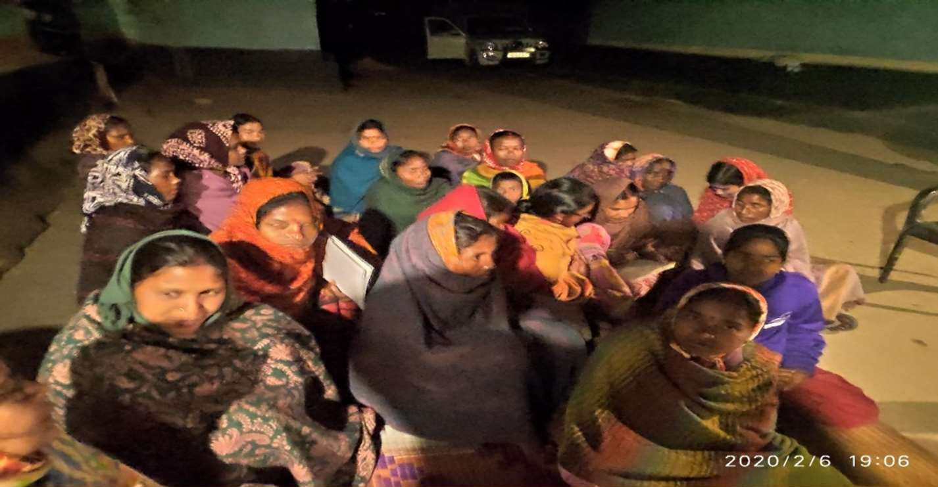

(a) Project beneficiaries of Bankura District during the mid-term assessment meeting. In almost all meetings women outnumbered men.

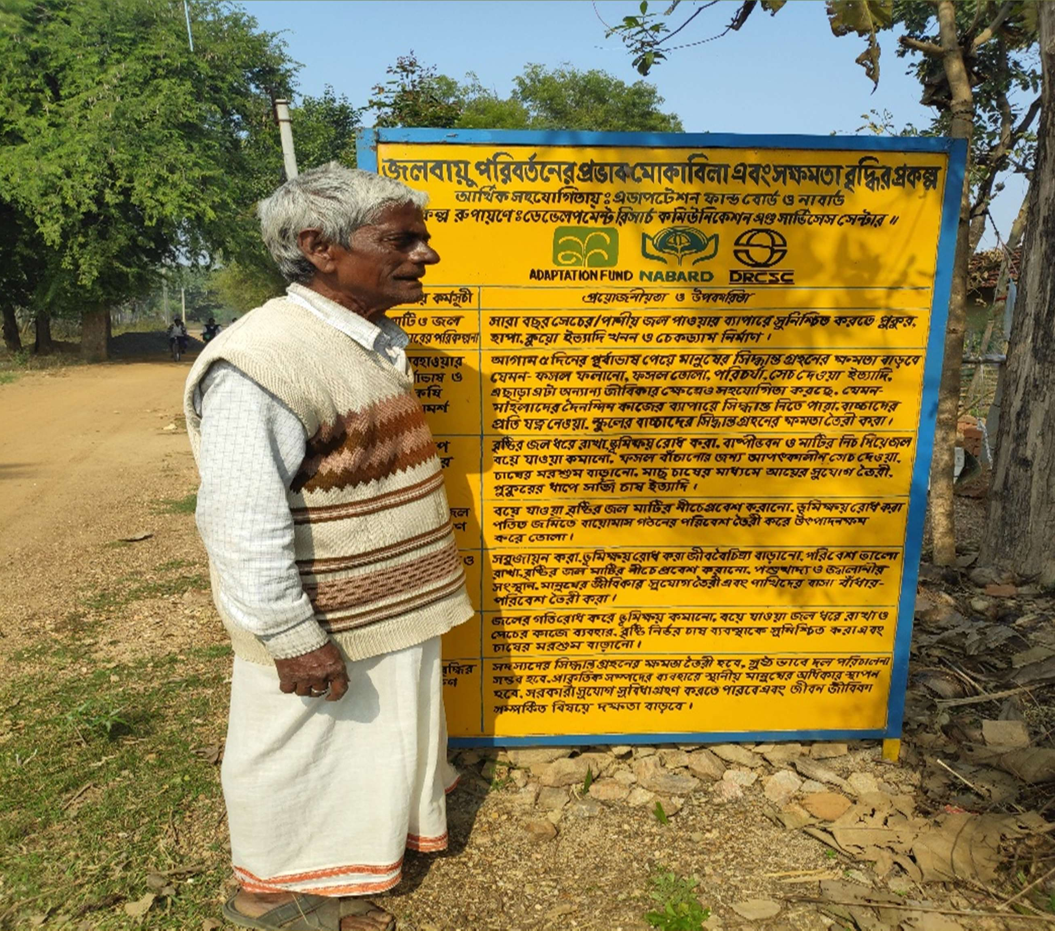

(b) Billboard describing the list of activities undertaken in the project village. Every project village has a similar billboard

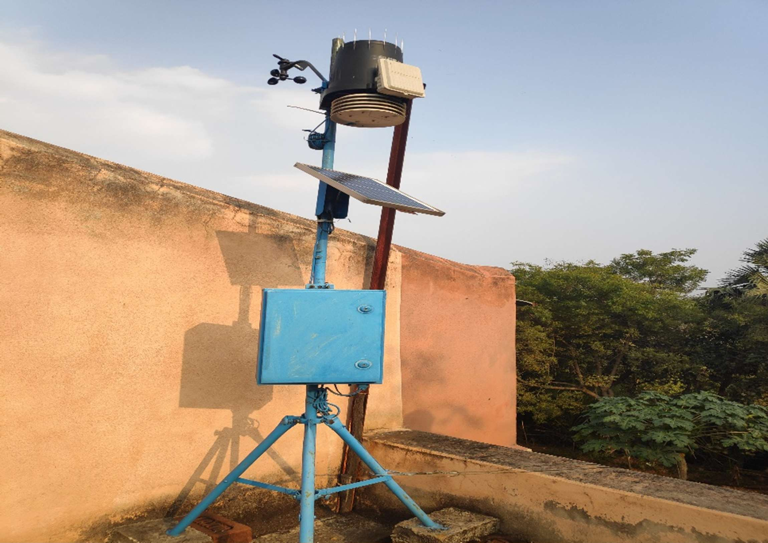

(c) Automated weather Station in one project location
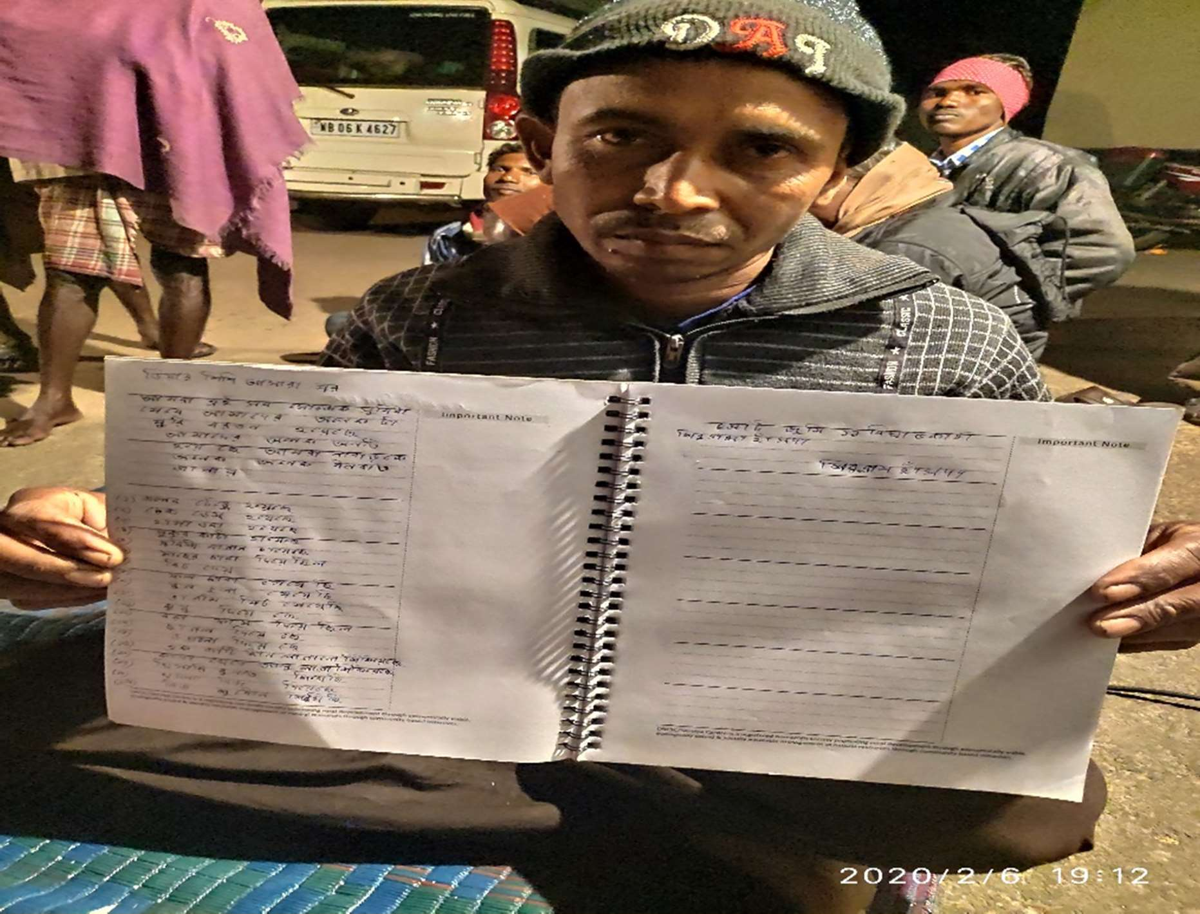

(D) A project beneficiary showing his written appreciation for NABARD for this project and some further requests

Figure 3: Pictures from the field showing interventions and beneficiaries

50

